RESOLUTION NO. 2024-70

A RESOLUTION OF THE PLANNING COMMISSION OF THE CITY OF VISALIA, RECOMMENDING APPROVAL OF ZONING TEXT AMENDMENT NO. 2024-02,
A request by the City of Visalia to amend Visalia Municipal Code TITLE 17 (Zoning ordinance) based on multiple factors including, but not limited to: STREAMLINING OF LAND USE REVIEW, CHANGES IN BUSINESS AND/OR DEVELOPMENT TRENDS AND ACTIVITY.

WHEREAS, Zoning Text Amendment No. 2024-02 is requested by the City of Visalia to amend Visalia Municipal Code Title 17 (Zoning Ordinance) based on multiple factors including, but not limited to: streamlining of land use review, changes in business and/or development trends and activity. The specific amendments apply City-wide and are specified in Attachment “A” of this Resolution; and

WHEREAS, the Planning Commission of the City of Visalia, after duly published notice, held a public hearing before said Commission on December 9, 2024; and

WHEREAS, the Planning Commission of the City of Visalia considered the Zone Text Amendment in accordance with Section 17.44.070 of the Zoning Ordinance of the City of Visalia and on the evidence contained in the staff report and testimony presented at the public hearing; and

WHEREAS, the project is exempt under the California Environmental Quality Act (CEQA) Guidelines section 15061(b)(3) (common sense exemption).

NOW, THEREFORE, BE IT RESOLVED that the Planning Commission recommends that the City Council concur that the project is exempt from further review under the California Environmental Quality Act (CEQA) Guidelines section 15061(b)(3) (common sense exemption).

BE IT FURTHER RESOLVED that the Planning Commission of the City of Visalia recommends approval to the City Council of the proposed Zone Text Amendment based on the following specific findings and evidence presented:
- That the Zoning Text Amendment is needed to achieve the objectives of the Zoning Ordinance (Visalia Municipal Code Title 17) prescribed in Code Section 17.02.020.
- That the proposed Zone Text Amendment is consistent with the intent of the General Plan, and Zoning Ordinance, and is not detrimental to the public health, safety, or welfare, or materially injurious to properties or improvements in the vicinity.
- The Zoning Text Amendment makes various updates based on changes in business and/or development trends, development activity, and streamlining of land use review.
- That the project is exempt from further review under the California Environmental Quality Act (CEQA) Guidelines section 15061(b)(3) (common sense exemption).
BE IT FURTHER RESOLVED that the Planning Commission of the City of Visalia recommends approval to the City Council of the Zone Text Amendment described herein in Attachment “A”, in accordance with the terms of this resolution and under the provisions of Section 17.44.070 of the Ordinance Code of the City of Visalia.
Commissioner Peck offered the motion to this resolution. Commissioner Davis seconded the motion and it carried by the following vote:

AYES: Commissioners Peck, Davis, Norman, Tavarez, Beatie
NOES:
ABSTAINED:
ABSENT:

STATE OF CALIFORNIA)
COUNTY OF TULARE ) ss
CITY OF VISALIA )

ATTEST: Paul Bernal, Community Development Director

I, Paul Bernal, Secretary of the Visalia Planning Commission, certify the foregoing is the full and true Resolution No. 2024-70, passed and adopted by the Planning Commission of the City of Visalia at a regular meeting held on December 09, 2024.

Paul Bernal, Community Development Director

Mary Beatie, Chairperson

Resolution No. 2024-70

ATTACHMENT “A”

Zoning Text Amendment No. 2024-02, implementing numerous amendments to Title 17 (Zoning Ordinance) based on factors including, but not limited to, streamlining of land use review, changes in business and/or development trends and activity.
Changes to City of Visalia Municipal Code, as specified by underline and italics for additions and strikeout for deletions.
CHAPTER 17.04 regarding new or modified definitions:
Section 17.04.030 Definitions.

“Event Centers” means a facility operated by any person, entity, or organization where private parties may hold weddings, receptions, special gatherings, or other social, civic, or entertainment activities. The facility may be indoors, outdoors, or a combination of both. This does not include retail sales, theaters, private clubs and lodges, athletic/playing fields, and hosting of sporting events. Other uses operated within the facility which are otherwise listed within the Zones Use Matrix, including but not limited to churches and specialized schools, may be allowed to utilize the facility without additional entitlements provided that such other uses are not the sole and primary use operated in the facility and are limited to indoor operation only.

“Media Studio” means a studio space dedicated to the recording, production, and/or editing of audio and/or visual art forms or the broadcast via radio, television, internet or other media of audio and/or visual art forms, or the combination of any of the above.

“Battery Energy Storage System” means a permanent facility that charges (i.e., collects energy) from an electrical grid or a power plant and then discharges that energy at a later time through an electrical grid.

“Residential Unit Reoccupation” means a single-family dwelling, situated in a non-residential zone classification and which does not contain any on-site commercial or office business, that occupies an existing structure that was originally fabricated for the intended purpose as a residential dwelling unit. The single-family dwelling may or may not have a business associated with a home occupation permit.

“Galleries” mean an establishment engaged in the sale, loan, or display of art, photography, crafts, paintings, sculpture, or other works of art. This clarification does not include libraries or museums.

“Animal Day Care Facility” means an establishment where dogs, cats, or other small domestic animals are provided such services as day care for all or part of a day, obedience classes, training, grooming, exercising, socializing, or behavioral counseling, provided that overnight boarding is not permitted.

“Kennel” means an establishment where dogs, cats, or other small domestic animals are boarded, trained, or bred.
“Animal Hospital” means an establishment for dogs, cats, or other small domestic animals to receive medical or surgical treatment, whether emergency or non-emergency, and are cared for during the time of such treatment. Use as short-time boarding (i.e., as necessary for medical observation, monitoring, and treatment) shall be only incidental to such hospital use. An animal hospital which provides short term boarding may operate 24 hours a day in an Industrial zone or if specified in a conditional use permit.

“Commercial Bakery” means an establishment that is primarily engaged in manufacturing bread, bread-type rolls, and dry bakery products. The establishment will either not directly sell on the premises to consumers, or will conduct limited sales on the premises to consumers as an ancillary use to the bakery.

“Commercial Kitchen” means a facility equipped to prepare food or meals to be delivered off-site to a residential and/or commercial establishment, wherein the space is not open to patrons on-site.

“Clothing Imprinting” means a commercial operation involving a process that is considered printing, imprinting, reproducing, or duplicating images and using printing methods upon clothing or garments, including but not limited to the use of stitching, sewing, lithography, and screen process printing.

“Museum” means an establishment serving as a repository for a collection of natural, scientific, or literary curiosities or objects of interest, or works of art, and arranged, intended, and designed to be used by members of the public for viewing, with or without an admission charge, and which may include as an accessory use the sale of goods to the public as gifts or for their own use, and the holding of meetings and social events.

“Convenience Stores” Means a small retail establishment, generally but not limited to under 7,000 square feet, which can be located within or associated with another use, that offers for sale convenience goods such as prepackaged food and drink items, periodicals, and other convenience goods or household items for the convenience of the neighborhood. Such establishments may include the sales of alcohol and/or tobacco products; however, the sale of each such line of products shall clearly be accessory to the overall range of goods offered within the establishment. Convenience stores which operate in a manner that meets the definition of “tobacco shop”, as defined in Section 8.46.030, shall be subject to the definition of “Tobacco Shop”. Convenience stores having the sale of alcohol which comprises the majority of gross sales shall be subject to the definition of “Liquor Store”, as defined in Section 17.04.030.

“Tutoring Center” Means an establishment providing instruction to students typically on an individual basis, for personal or professional enrichment, involving scholastic, non-physical pursuits, including but not limited to academics, language instruction, music instruction, and computer training. Establishments providing instruction as a part of a certificate or degree granting program are not to be considered a Tutoring Center and subject to the most appropriate use found in the “Schools, Public and Private” section of Table 17.25.030.

“Car Sales” means the use of any building or premises, or portion thereof, as a retail establishment for the display and sale of new and/or used motor vehicles. The use may also conduct warranty repair work and other repair service and the sales of parts and accessories as an accessory use to the sale of motor vehicles. This definition does not include an establishment that does not display any on-site vehicles, as such use shall be classified as a professional office.

“Clinic” means a medical facility that operates as an urgent care or walk-in clinic, or is a multi-disciplinary or specialty medical group practice, that is limited to outpatient services or surgeries only and does not provide overnight stays. Treatment at the facility is provided by two or more physicians, dentists, or other professionals that provide health care, chiropractic, psychiatric, or psychology services. This classification does not include hospitals.

"Medical Officebuildings" means a medical facility that operates as an appointment-based medical group practice, that is limited to outpatient services or surgeries only and does not provide overnight stays. Treatment may be provided by one or more of the following: physician, dentist, optometrist, physical therapist, chiropractor, psychiatrist, psychologist, or similar health care professionalclinics or offices for doctors, dentists, oculists, chiropractors, osteopaths, chiropodists, or similar practitioners of the healing arts; including accessory laboratories and a prescription pharmacy, but not including offices for veterinarians.

“Professional Office” means a place of employment occupied by a person or persons generally employed in a professional, administrative, or clerical position. This definition includes offices for accountants, advertising agencies, insurance agents, commercial art and design services, non-retail financial institutions, real estate agents, architects, engineers, employment agencies, real-estate agents, counselors, and other similar professions. This does not include offices for persons employed in a medical field. Counseling or therapy services shall not include medical examinations, dispensing of drugs or medication, or other treatments normally conducted in a hospital or clinic.

“Professional Office with Social Services” means a professional office that generally provides group counseling or therapy services in a non-medical setting which includes the providing of social services or wraparound services, life skills training, recovery sessions for substance abuse, food distribution (not for on-site consumption), clothing distribution, and other programs not involving drug dispensing or psychologist counseling. This does not include offices for persons employed in a medical field, nor does it include any type of emergency shelter.

“Vocational or other Specialized Schools – Non-industrial Trades” means a school established to provide for the teaching of professional clerical, managerial, artistic, or similar skills or trades. This definition applies to schools that are owned and operated privately for profit, or not-for-profit, and that do not offer a complete educational curriculum. Examples include, but are not limited to, beauty, modeling, culinary, cosmetology, arts and media, music, accounting and finance, health and dental including nursing, legal, psychology, and technology. The definition does not include uses wherein the building contains a space dedicated for training of workforce skills, wherein the space is ancillary to the primary use.

“Vocational or other Specialized Schools – Industrial Trades” means a school established to provide for the teaching of industrial skills. This definition applies to schools that are owned and operated privately for profit, or not-for-profit, and that do not offer a complete educational curriculum. Examples include, but are not limited to, construction, industrial occupations, truck driving, machinery, vehicle repair and maintenance, and welding. The definition does not include uses wherein the building contains a space dedicated for training of workforce skills, wherein the space is ancillary to the primary use.

“Indoor Amusement Facilities” means an establishment that provides entertainment activities or services in an indoor setting for a fee or admission charge. This definition includes uses that are listed separately in the zone use matrix (i.e. athletic and health clubs (racquet clubs), bowling alleys, ice & roller skating rinks pool halls, arcades, escape rooms, indoor playgrounds and trampoline parks). Uses which are not listed separately in the zone use matrix shall be classified as other Indoor Amusement Facilities.

“Escape Room” means a type of indoor amusement facility consisting of one or more rooms wherein a group of persons within a room must solve a series of tasks and puzzles in order to exit from the room.

“Personal Services” Means establishments that provide personal nonmedical elective procedures for the purpose of self-care. Procedures includes but is not limited to barber and beauty shops, day spas, tanning centers, and cosmeticians. These uses may include certain elective procedures for the improvement of health but not deemed necessary for improving health, such as botulinum toxin injections, laser hair removal, microneedling, medical spas, and similar aesthetic treatments. These uses may also include accessory retail sales of products related to the services provided. This definition does not include massage establishments or an establishment which includes massage services.

“Heavy Manufacturing” means manufacturing of materials in a raw form. Any industrial use that generates considerable noise, odor, vibration, illumination, or particulate that may be offensive or obnoxious to adjacent land uses or requires a significant amount of on-site hazardous chemical storage shall be classified under this land use. This use shall include any packaging of the product being manufactured on-site. Examples include but are not limited to the production of the following: agricultural equipment, aircraft equipment parts & supplies, large appliances, auto/truck manufacturing, industrial machinery.

“Light Manufacturing” means assembling or mixing, where previously processed components or manufactured parts produced off-site are fitted together into a complete machine or blended together to form a non-combustible and non-explosive product. The assembling or packaging shall not produce noise, vibration, hazardous waste materials, or particulate that create significant negative impacts to adjacent land uses. Odors produced on-site shall not negatively affect other businesses or properties in the area. Examples of assembling include but are not limited to the production of the following: computer hardware & parts, electric supplies, consumer goods, toys, mechanical components, industrial machinery, small vehicle assembly.

“Hobby/Craft Manufacturing” means establishments manufacturing and/or assembling small products primarily by hand, including but not limited to jewelry, pottery and other ceramics, as well as small glass and metal art and craft products.

“Prototype Manufacturing or Makerspace” means a non-production scale manufacturing in an incubator workspace environment that can include such activities as machining, plasma cutting, sandblasting, ventilated painting, forging, casting, ceramics, and similar other industrial processes. Such workspaces may utilize tools and equipment including but not limited to three-dimensional (3D) printers, laser cutters, computer numerical control (CNC) machines, soldering irons, blacksmith equipment, and woodworking machinery.

Chapter 17.24 regarding uses in Business Research Park Zone

Section 17.24.010 Purpose.

B. The purpose and intent of the planned business research park zone district is to provide for business, scientific, educational, medical offices, and light industrial uses in a campus-type setting. Planned business research parks are to be planned and developed as integrated units via specific or master plans and are intended to accommodate large-scale office developments at locations that provide close-in employment opportunities; promote Visalia's community identity through special site development standards such as lot sizes, setbacks, landscaping, building scale, parking, open areas, etc.; and provide on-site ancillary uses including day care, food service, banks, recreation, etc., served by a variety of transportation modes to reduce vehicle trips.

CHAPTER 17.25 regarding new, modified, or deleted Zone Use Table line items:

In this section, changes are specified by underline for additions and strikeout for deletions.

Section 17.25.030 Commercial, Office, and Industrial Zone Use Table.

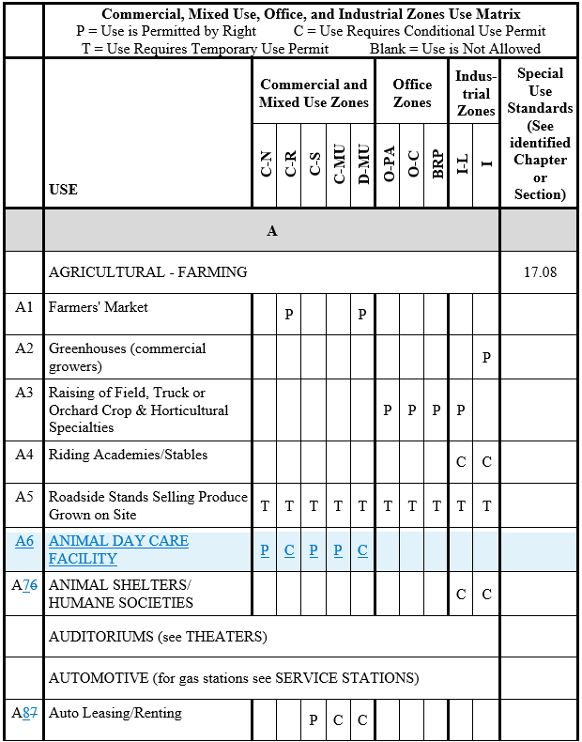
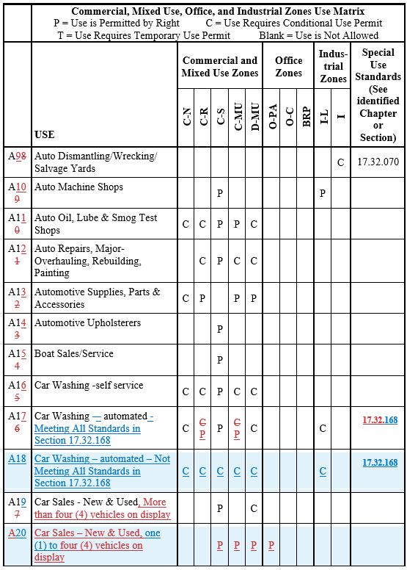
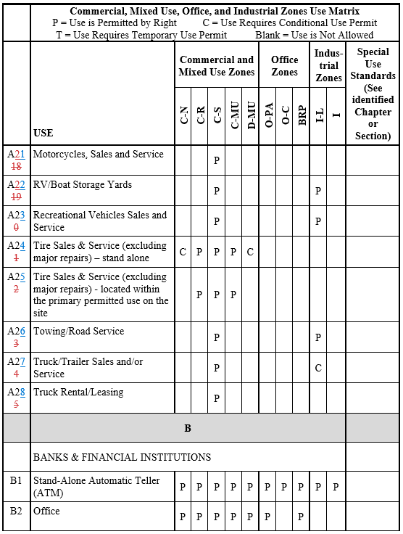

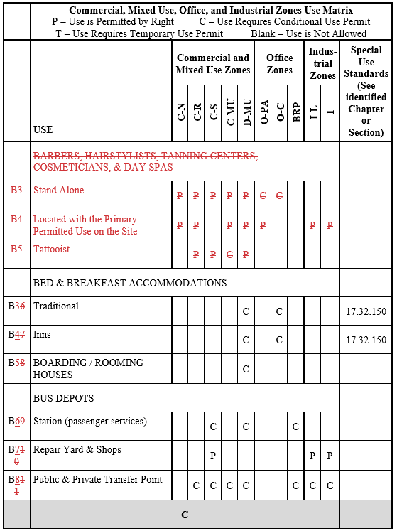

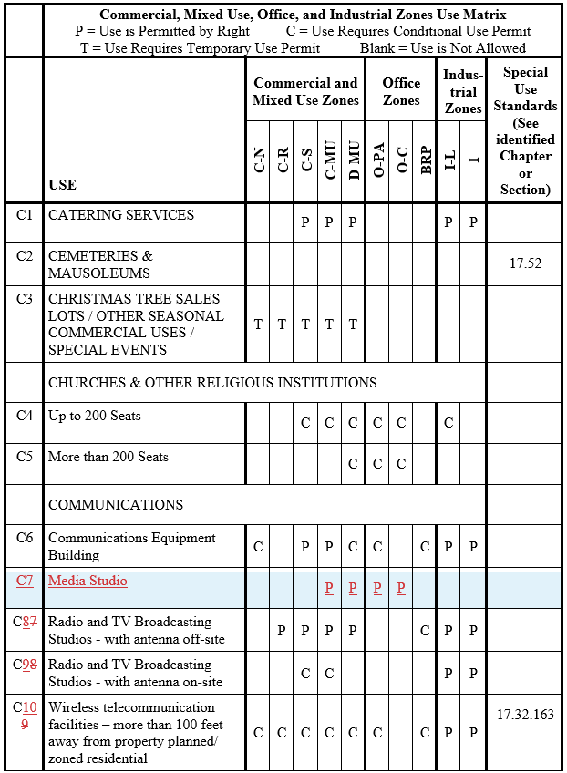
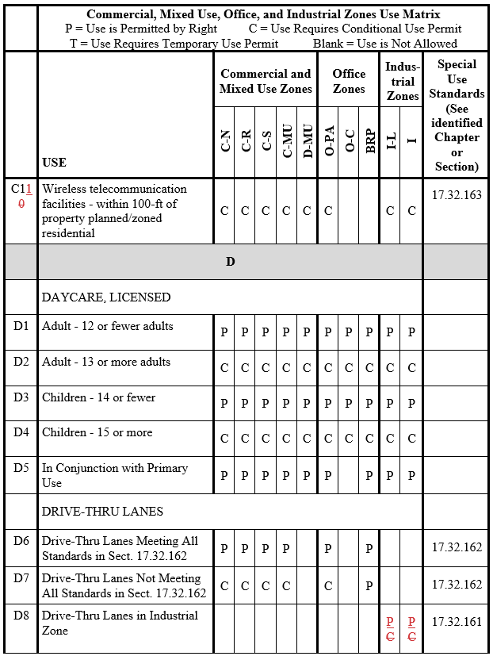

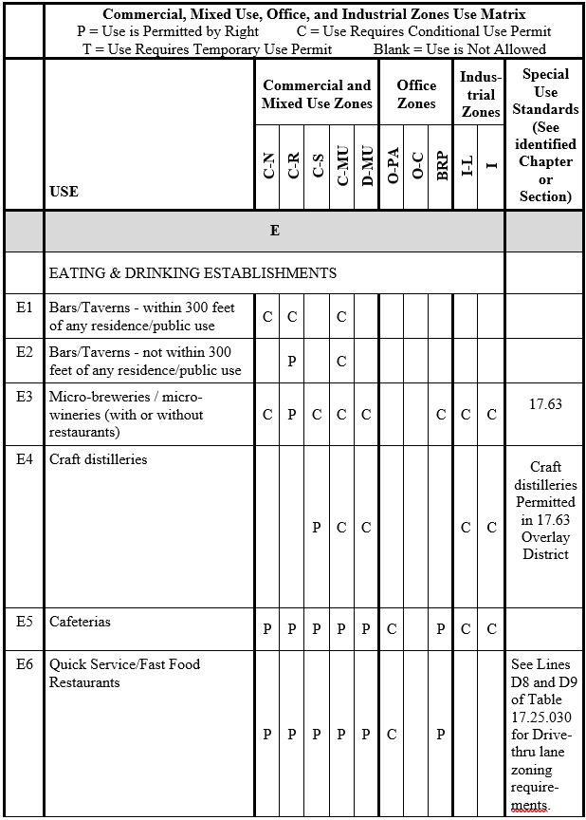

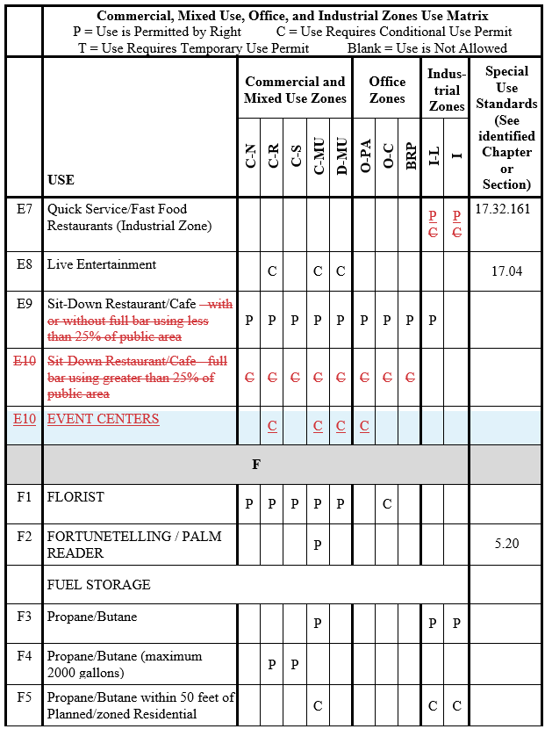

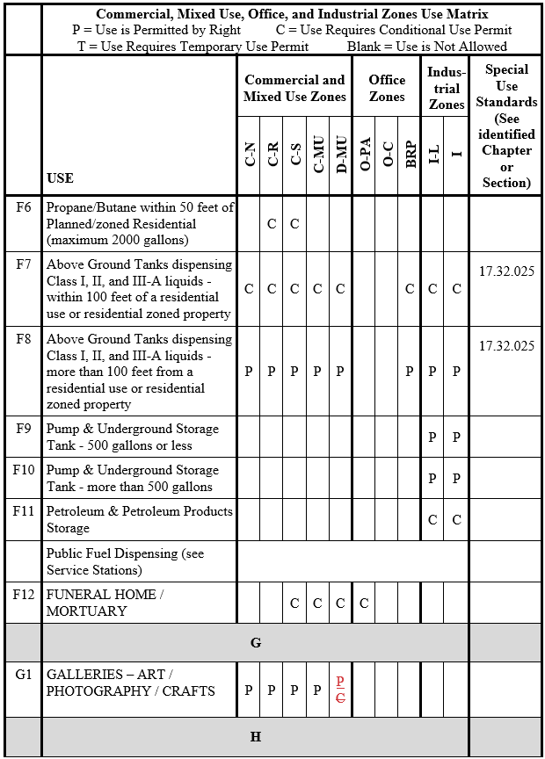

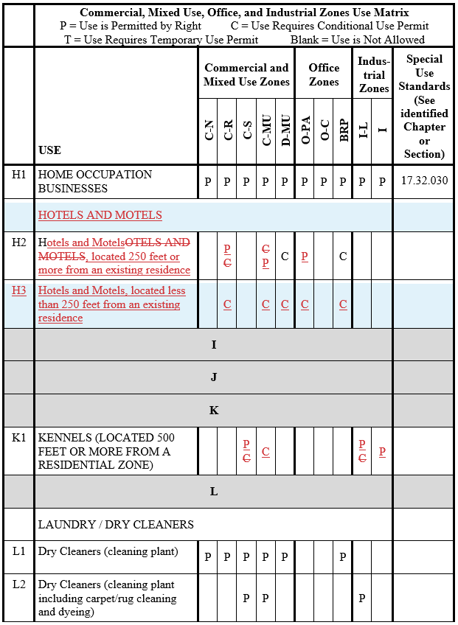

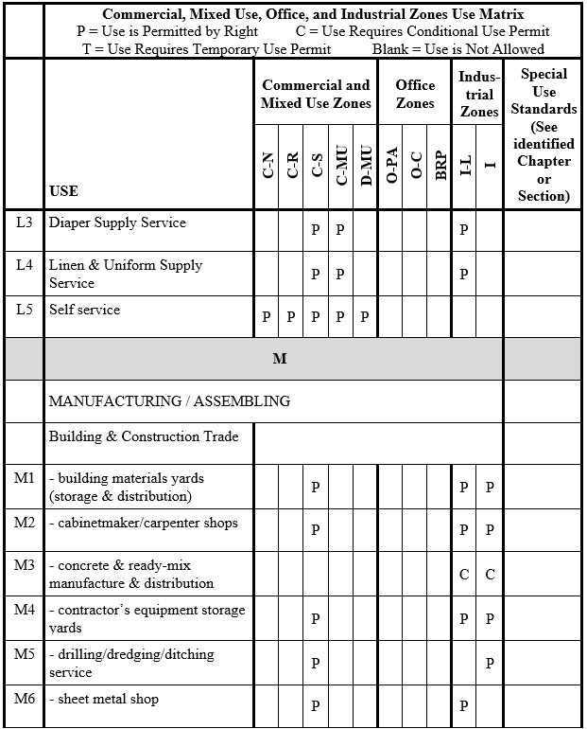

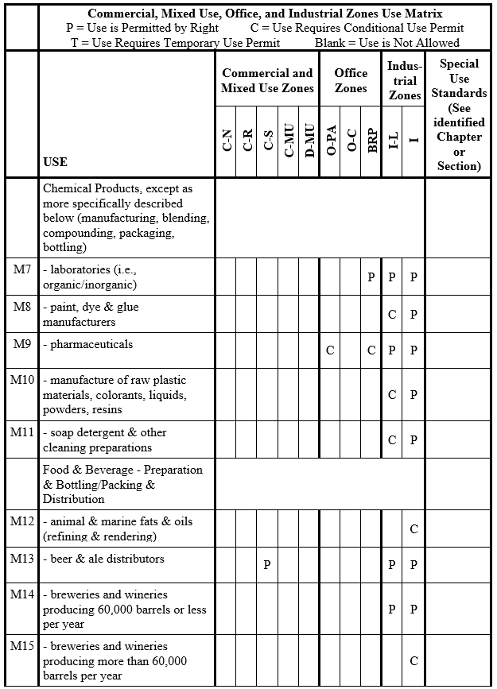

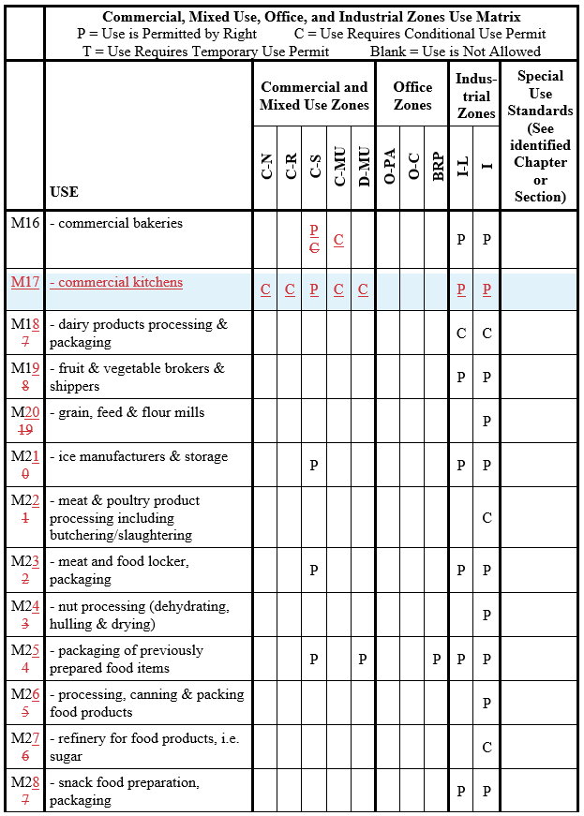

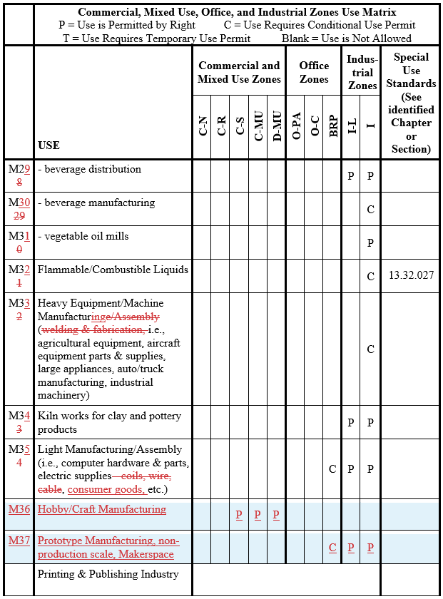

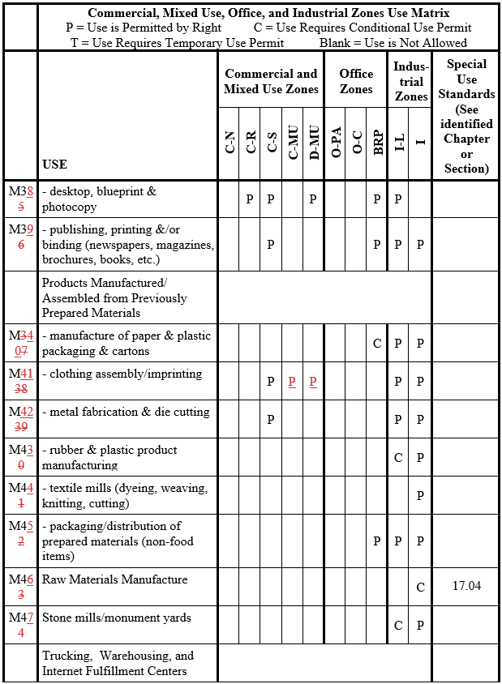

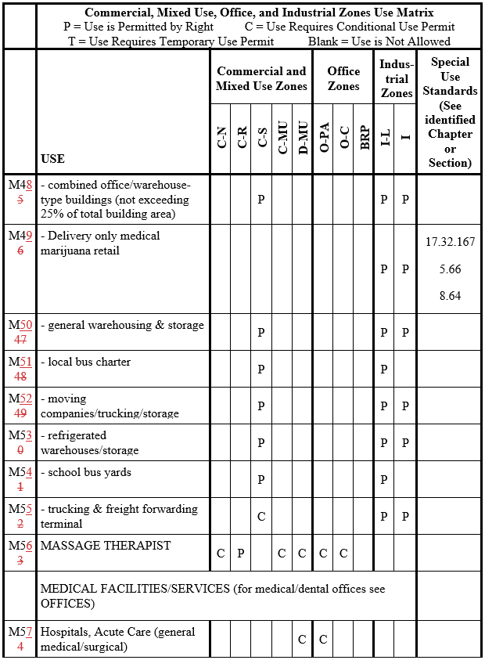

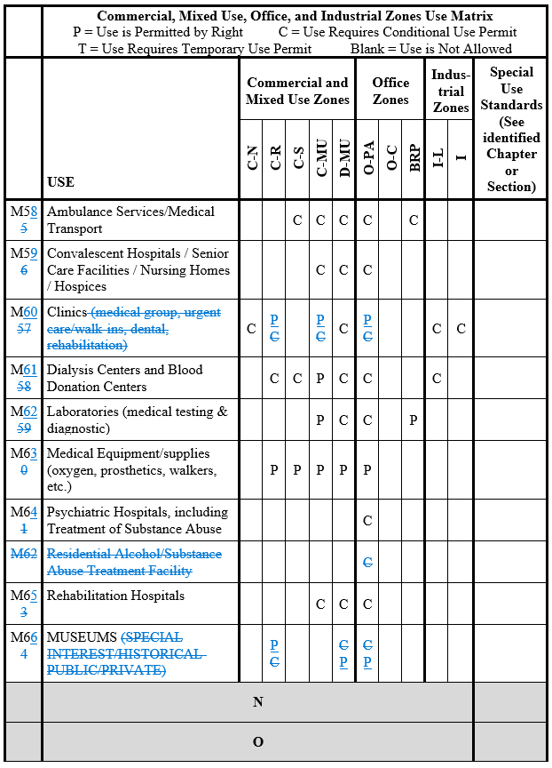

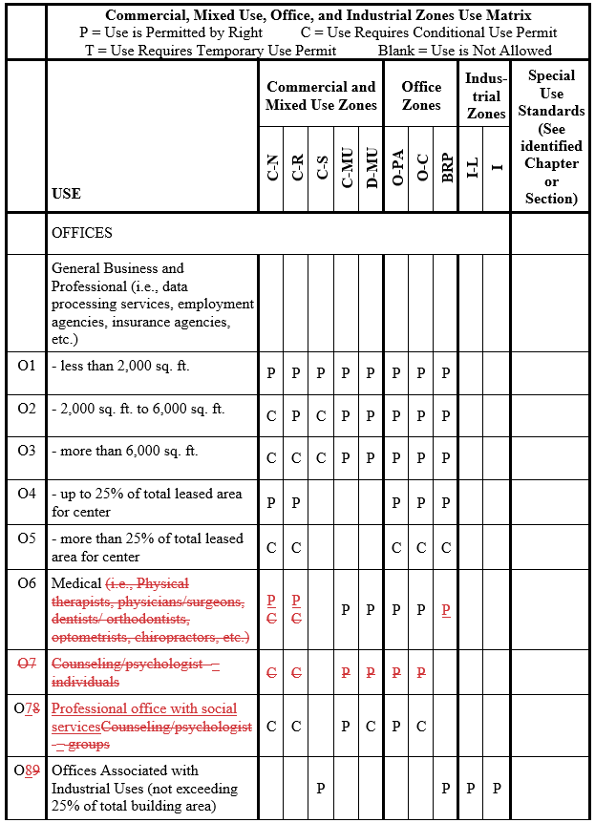
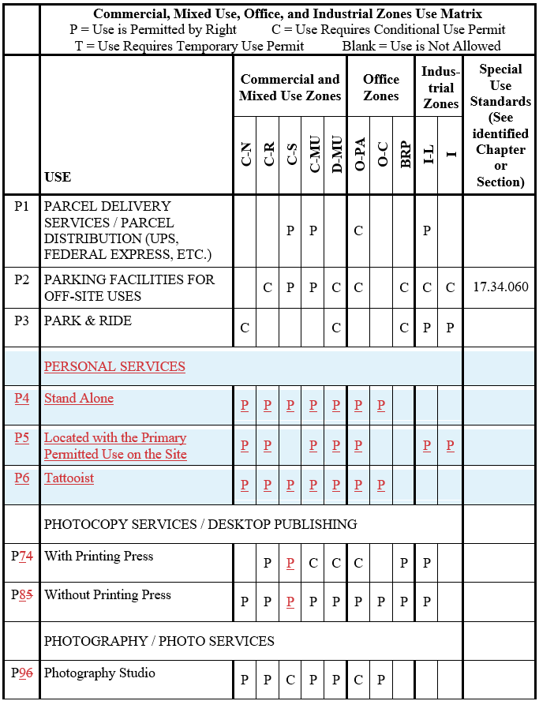

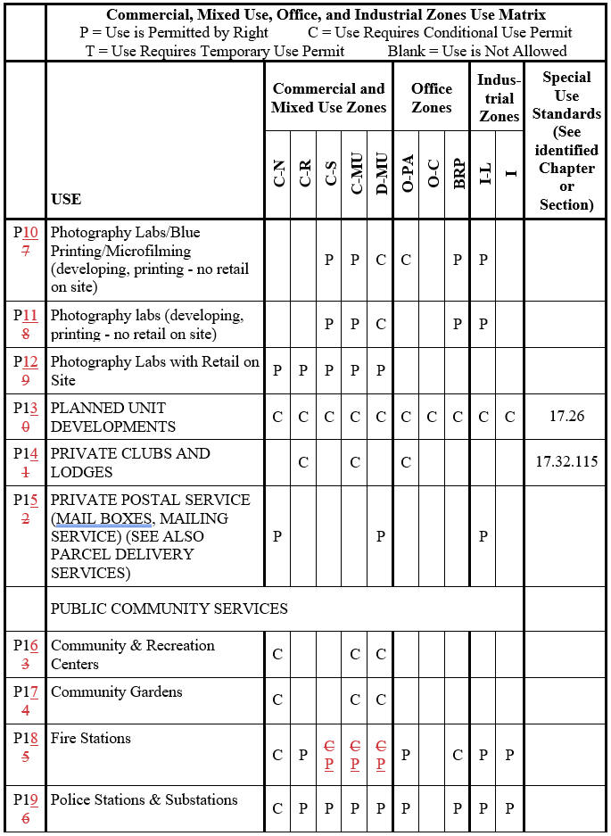

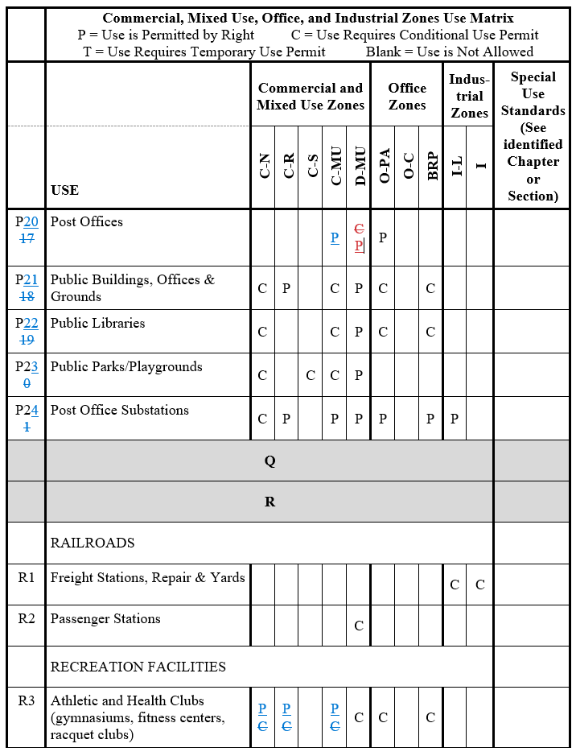

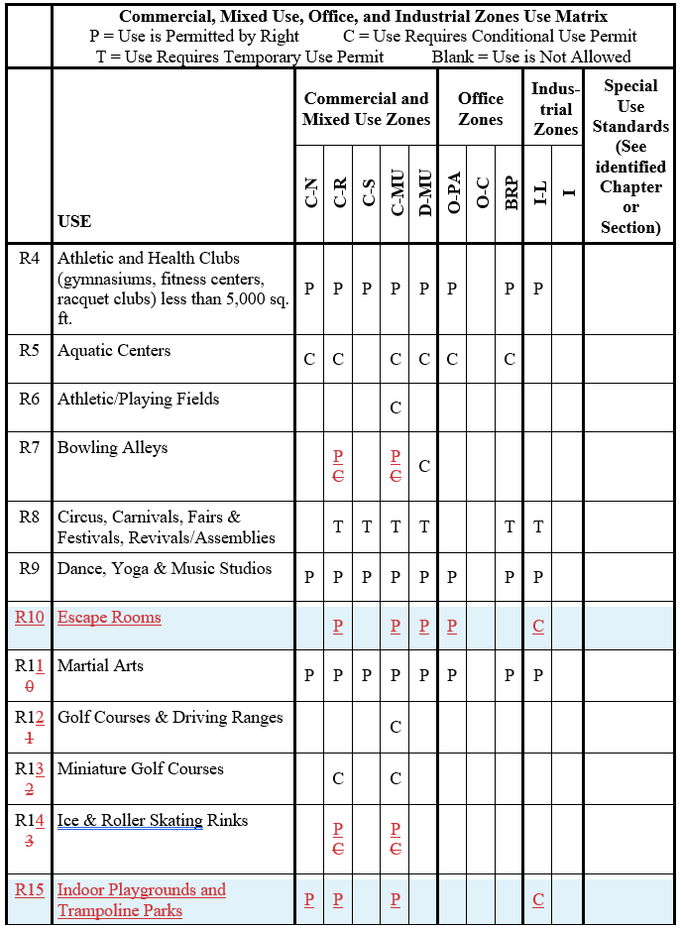
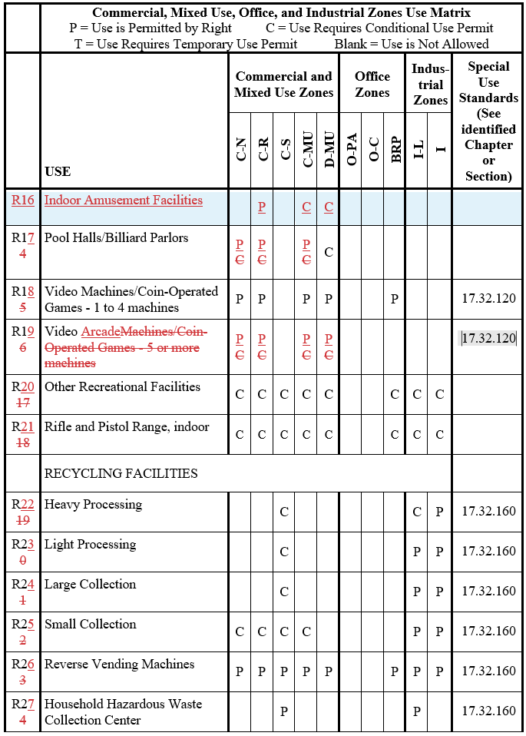

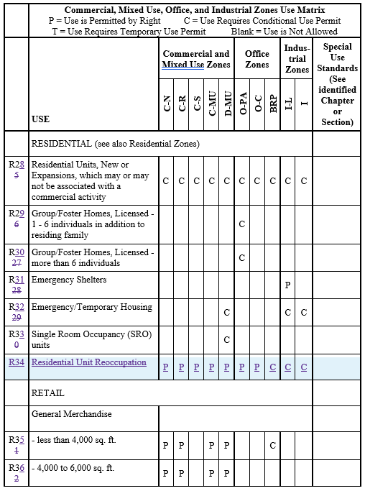
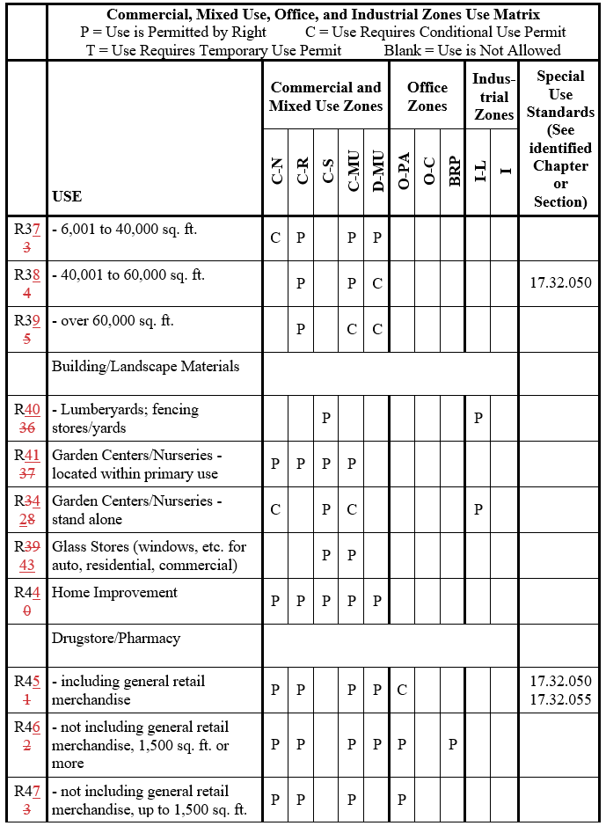
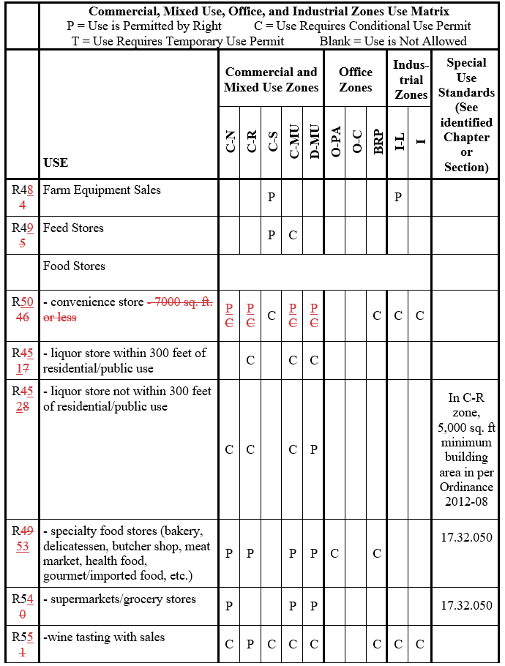
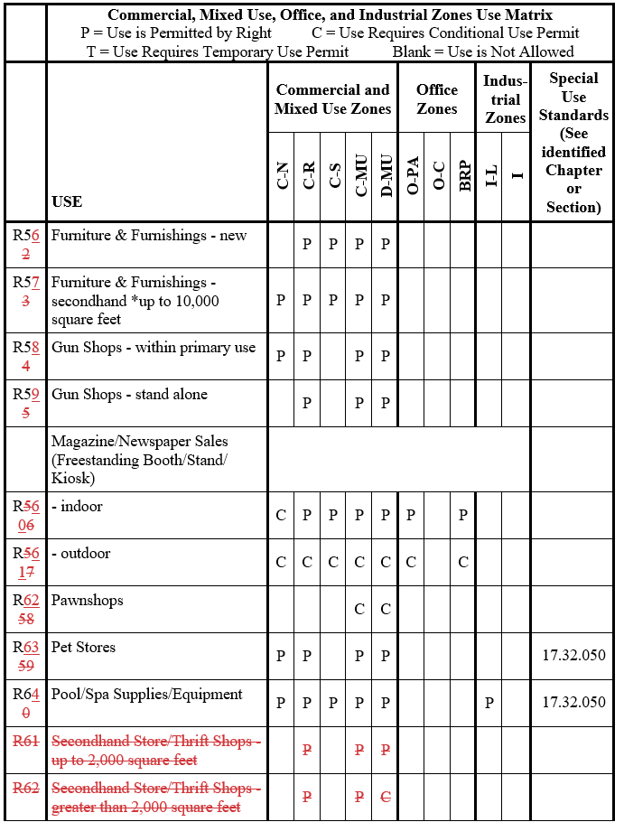

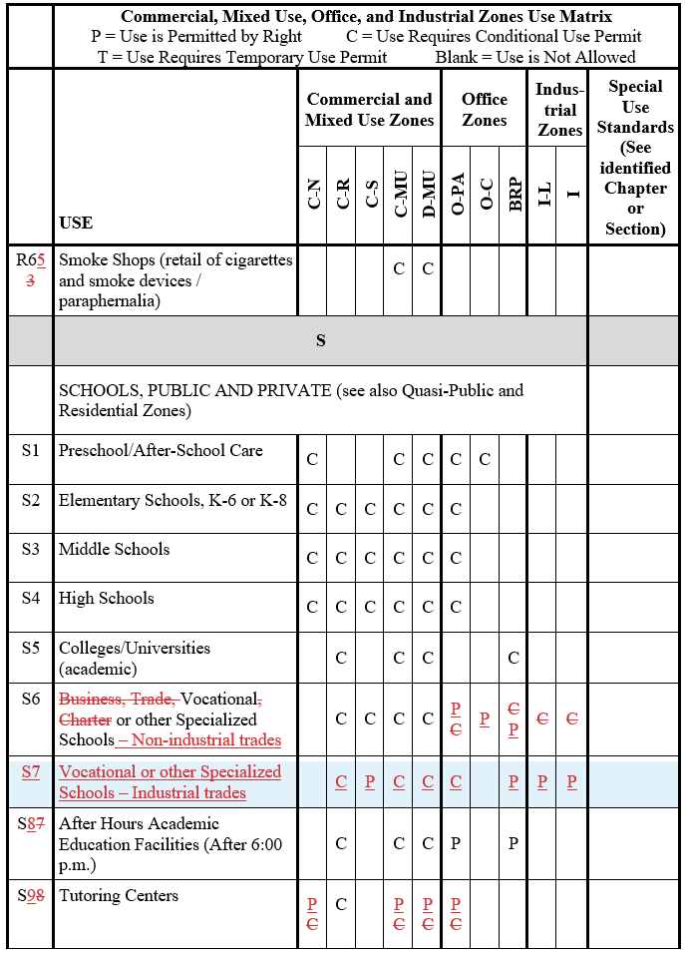

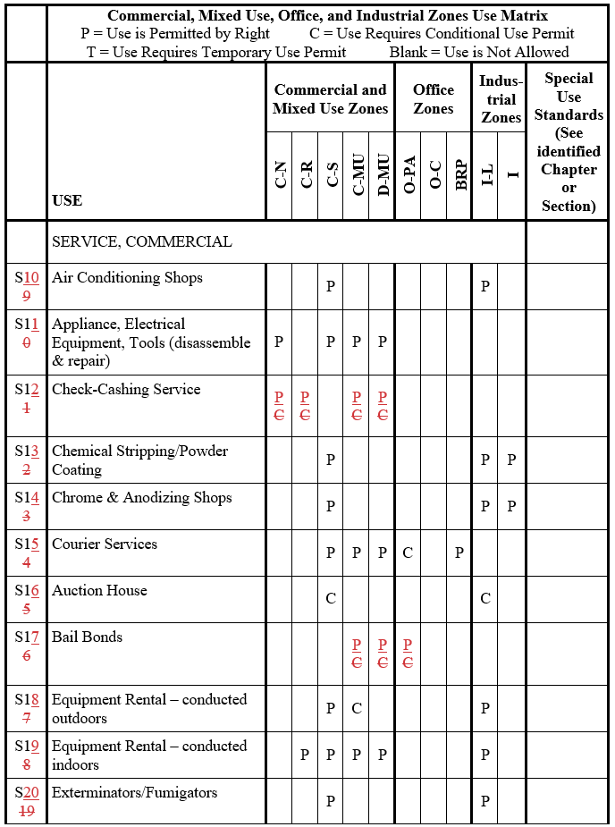
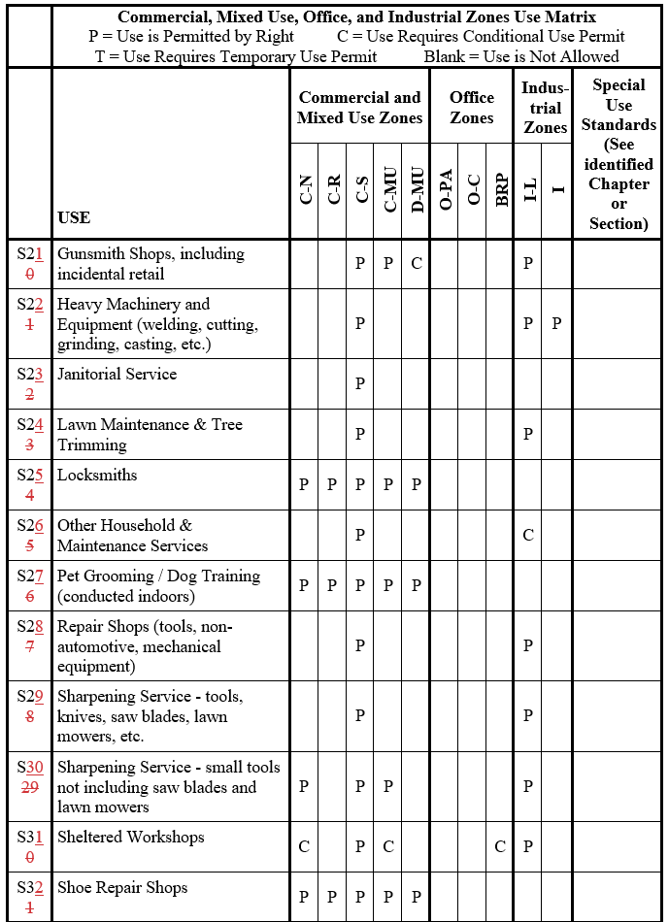

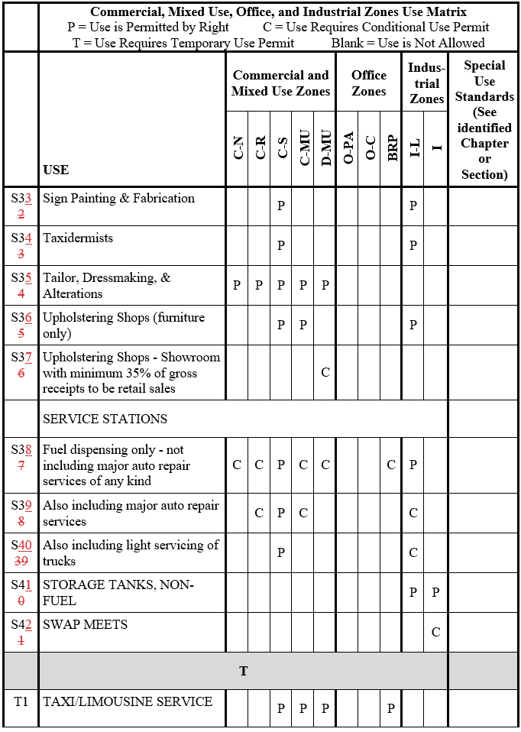

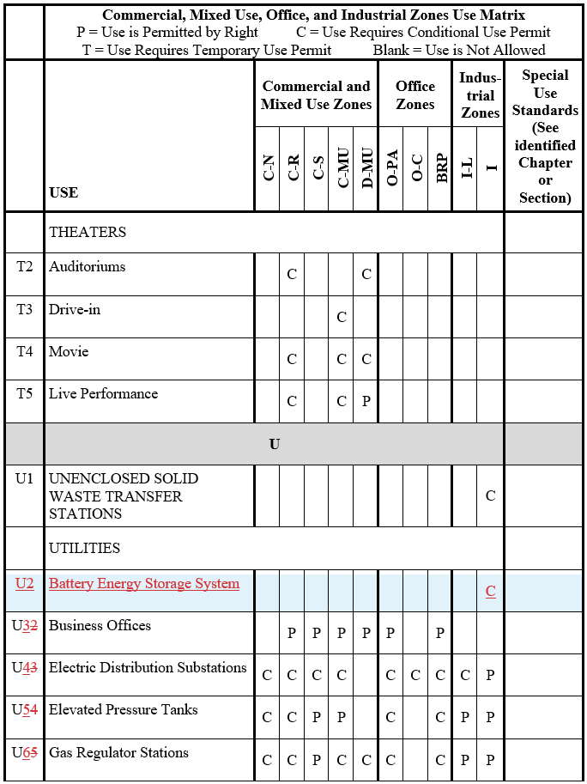

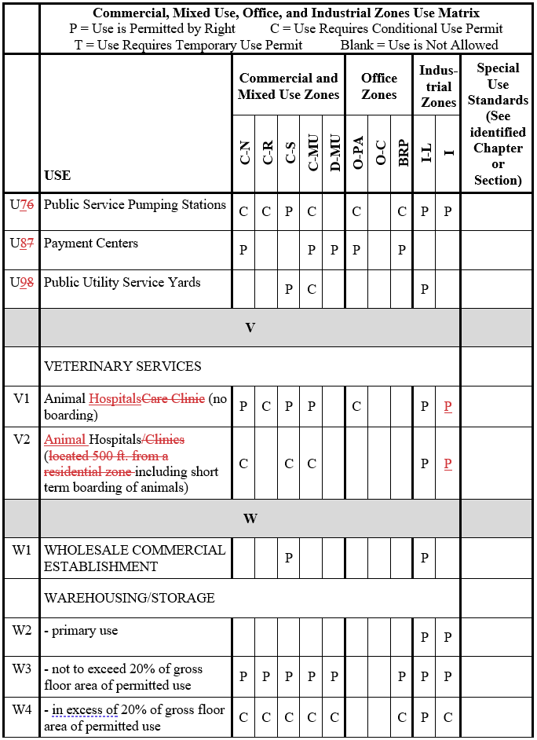

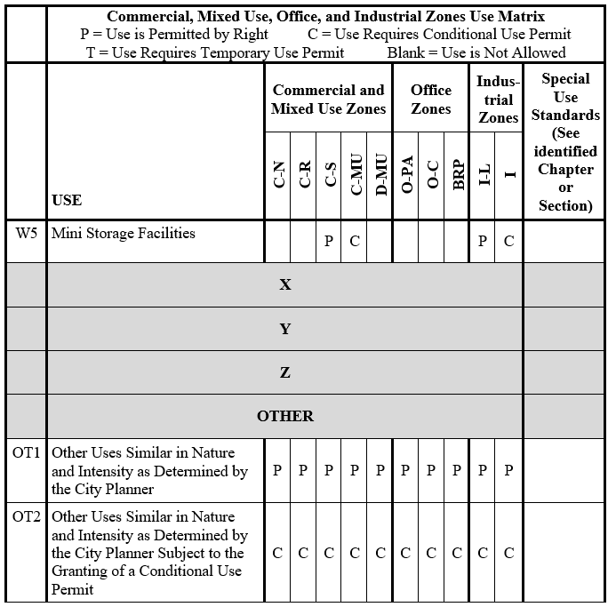

CHAPTER 17.32 regarding new or modified Special Provisions:

Section 17.32.168 Automated Car Washes
A. The queue lane shall not be visible from the public right-of-way. This shall be achieved by designing the site in a manner such that the queue lane is not located parallel with public street frontages, or by incorporating screening along a queue lane to a minimum height of three feet utilizing a combination of berms, hedges, and/or landscape materials, or solid walls if necessary.
B. The queue lane for entering the car wash structure shall not be located within 25 feet of a residential-zoned property or a parcel containing an existing residence or a sensitive receptor.
C. A noise analysis addressing noise impacts in conformance with the City of Visalia’s Noise Ordinance (Chapter 8.36) shall be required and accepted by the City Planner if the car wash is located within 1,000 feet of an existing residence or a sensitive receptor. Compliance of the noise levels, subject to the Visalia Noise Ordinance, shall be verified by the acoustical consultant or their designee prior to operation.
D. For car washes requiring a noise analysis, hours of operation beyond 7:00 p.m. shall only be permissible if supported by a noise analysis that confirms the car wash will not be inconsistent with the City of Visalia’s Noise Ordinance (Chapter 8.36).
E. A traffic study which analyzes the impact of the proposed carwash on adjacent and nearby intersections may be required. The limits of this study shall be established by the City Engineer.
F. Adequate means of eliminating grease and oils from drainage systems shall be provided, such as through the installation of a sand-oil separator.
17.32.120 Video machine arcades.
It is the purpose of this section to set forth development and operational standards for arcades. Such standards are adopted to protect the public welfare from potential problems associated with the operation of video machine arcades.
A. Definitions. For the purpose of this section the following definitions shall apply:
"Video arcade" means a commercial establishment that contains five or more "video machines.” and its primary business is generated from sales occurring through use of the “video machines.” Businesses that operate “video machines” as an ancillary use are not considered “video arcades.”
"Video machine" means any machine, device or apparatus, the operation or use of which is permitted, controlled, allowed or made possible by the deposit or placing of any coin, plate, disc, slug, or key into any slot, crevice or other opening or by the payment of any fee or fees, for the use as a game, contest, which is operated through the use of electronic means with images and sounds transmitted through a cathode ray tube.
B. Permits Required.
1. Video arcades may be approved as a conditional permitted use in the C-N, C-R, C-MU and D-MU zones pursuant to Chapter 17.38 of the Visalia zoning regulations.
2. Video machines, up to four in number, may be approved by the planning department pursuant to Section 17.38.070 (temporary uses) of the zoning regulations. Such permits shall be subject to the operational criteria set forth in subsection (C) of this section.
CB. Operational Criteria.
1. Location. Video machines and arcades shall not be located closer than six hundred (600) feet to any public schools, grades kindergarten through twelfth grade.
2. Hours of Operation. Normal hours of operation shall be between the hours of ten10:00 a.m. and eleven11:00 p.m. unless alternate hours are approved by the city council as part of a conditional use permit. Machines located in businesses may be operated during normal business hours if approved by the planning department(four or fewer machines) or city council (arcades). In any case, school aged children shall be prohibited from operating video machines while school is in session.
3. Security/Supervision. The use shall be under the supervision of an adult during all hours of operation. Additional supervision or security may be required as deemed necessary by the city council under the terms of the conditional use permit. The work station of the adult attendant shall be such that the entry and immediate outside area is visible. Supervision responsibility shall extend to the public and/or parking areas in the vicinity of the arcade.
4. Alcoholic Beverages. No alcoholic beverages shall be allowed to be bought or consumed on the premises, including the public and/or private areas in the vicinity. This shall not apply to businesses that are licensed and approved for alcoholic beverage sale and use, such as a bona-fide restaurant.
5. Noise. No noise or sound generated by an arcade shall be audible outside of the arcade building.
6. Loitering. Gathering and loitering of individuals in the arcade and public and/or parking areas in the vicinity of the arcade shall be prohibited.
DC. Monitoring of Use. Periodic inspections, which may or may not be announced in advance, may be conducted by the city to ascertain compliance of any arcade with these operational standardsthe conditions of the use permit under which the arcade is operating. Violations of the conditional use permit or the provisions of this section shall be subject to enforcement under the provisions of Chapter 17.46 of the zoning regulations. Continuing violations may lead to revocation of the conditional use permit for an arcade, as set forth under Section 17.38.040 of the zoning regulations. (Ord. 2017-01 (part), 2017: prior code § 7488)

