ORDINANCE NO. 2025-01

AN ORDINANCE OF THE CITY COUNCIL OF THE CITY OF VISALIA APPROVING ZONING TEXT AMENDMENT NO. 2024-02,
amendING Visalia Municipal Code TITLE 17 (Zoning ordinance) based on multiple factors including, but not limited to: STREAMLINING OF LAND USE REVIEW, CHANGES IN BUSINESS AND/OR DEVELOPMENT TRENDS AND ACTIVITY, CITYWIDE.

WHEREAS, Zoning Text Amendment No. 2024-02 is requested by the City of Visalia to amend Visalia Municipal Code Title 17 (Zoning Ordinance) based on multiple factors including, but not limited to: streamlining of land use review, changes in business and/or development trends and activity, with the specific amendments applying City-wide; and

WHEREAS, the Planning Commission of the City of Visalia, after duly published notice, held a public hearing before said Commission on December 9, 2024; and

WHEREAS, the Planning Commission of the City of Visalia considered the Zone Text Amendment in accordance with Section 17.44.070 of the Zoning Ordinance of the City of Visalia and on the evidence contained in the staff report and testimony presented at the public hearing; and

WHEREAS, the City Council of the City of Visalia, after duly published notice, held a public hearing before said City Council on January 21, 2025, and introduced said Ordinance for first reading on that date.

WHEREAS, the proposed Zoning Text Amendment is consistent with the intent of the General Plan, and Zoning Ordinance, and is not detrimental to the public health, safety, or welfare, or materially injurious to properties or improvements in the vicinity.

WHEREAS, that the proposed Zoning Text Amendment is not inconsistent with any other Element of the General Plan.

NOW, THEREFORE, BE IT RESOLVED that the City Council concurs the project is exempt from environmental review under California Environmental Quality Act (CEQA) Guidelines section 15061 (b) (3), which states that the project is exempted from CEQA if the activity is covered by the commonsense exemption that CEQA applies only to projects that have the potential for causing a significant effect on the environment. Where it can be seen with certainty that there is no possibility that the activity in question may have a significant effect on the environment, the activity is not subject to CEQA.

NOW, THEREFORE, BE IT FURTHER RESOLVED the City Council of the City of Visalia finds that the Zoning Text Amendment is consistent with the intent of the General Plan and Zoning Ordinance, and is not detrimental to the public health, safety, or welfare, or materially injurious to properties or improvements.
NOW, THEREFORE, BE IT ORDAINED BY THE CITY COUNCIL OF THE CITY OF VISALIA:

That Zoning Text Amendment (ZTA) No. 2024-02, is approved, as contained in Exhibit A of this Ordinance, in accordance with the terms of this resolution and under the provisions of Section 17.44.090 of the Ordinance Code of the City of Visalia.

Zoning Text Amendment No. 2024-02
Ordinance No. 2025-01
EXHIBIT “A”

Section 1. The Visalia Municipal Code shall be changed as follows.

Section 2. Chapter 17.04 regarding new or modified definitions.

Changes to City of Visalia Municipal Code, as specified by underline and italics for additions and strikeout for deletions.

Section 17.04.030 Definitions.

The definitions set forth in this chapter shall apply to this title.
"Affordable housing" means, under state and federal statutes, housing that costs no more than thirty (30) percent of gross household income. Housing costs include rent or mortgage payments, utilities, taxes, insurance, homeowner association fees, and other related costs.
''Agricultural employee housing" shall have the same meaning as that term is defined in California Health and Safety Code Section 17008.5, specifically meaning housing occupied by an employee of an agricultural employer, as defined in Section 1140.4 of the Labor Code, or by a farm labor contractor, as defined in Section 1682 of the Labor Code.
"Alley" means a public way reserved as a secondary means of vehicular access to abutting property that is twenty-four (24) feet in width or less.
"Alter" means to do work that does not result in enlarging a building but that will prolong the life of the structure.
“Animal Day Care Facility” means an establishment where dogs, cats, or other small domestic animals are provided such services as day care for all or part of a day, obedience classes, training, grooming, exercising, socializing, or behavioral counseling, provided that overnight boarding is not permitted.

“Animal Hospital” means an establishment for dogs, cats, or other small domestic animals to receive medical or surgical treatment, whether emergency or non-emergency, and are cared for during the time of such treatment. Use as short-time boarding (i.e., as necessary for medical observation, monitoring, and treatment) shall be only incidental to such hospital use. An animal hospital which provides short term boarding may operate 24 hours a day in an Industrial zone or if specified in a conditional use permit.

"Auction House" means an establishment where the real or personal property of others is sold by a broker or auctioneer to persons who attend scheduled sales or events.
"Bail Bonds" means a facility that provides bail bonds, documents that ensure to the court system that a person facing charges, and who typically is in jail, will appear for future court appointments if released.
“Battery Energy Storage System” means a permanent facility that charges (i.e., collects energy) from an electrical grid or a power plant and then discharges that energy at a later time through an electrical grid.

"Boarding/Rooming house" means a dwelling in which lodging and meals are provided for compensation for more than three but not more than fifteen (15) persons not including members of the principal occupant's immediate family. Nursing homes as defined in this section are specifically not included.
"Block" means the properties abutting on one side of street and lying between intersections or between an intersection and the end of a street.
"Building" means any structure having a roof supported by columns or walls, for the housing or enclosure of persons, animals or chattels or property.
“Car Sales” means the use of any building or premises, or portion thereof, as a retail establishment for the display and sale of new and/or used motor vehicles. The use may also conduct warranty repair work and other repair service and the sales of parts and accessories as an accessory use to the sale of motor vehicles. This definition does not include an establishment that does not display any on-site vehicles, as such use shall be classified as a professional office.

"Check Cashing Facility" means a person or business that for compensation engages, in whole or in part, in the business of cashing checks, payday advances, warrants, drafts, money orders or other commercial paper serving the same purpose. "Check cashing facility" does not include a State or Federally chartered bank, savings association, credit union or industrial loan company. "Check cashing facility" does not include a retail seller engaged primarily in the business of selling consumer goods, including consumables, to retail buyers that cash checks or issue money order for minimum flat fee as a service that is incidental to its main purpose or business.
“Clinic” means a medical facility that operates as an urgent care or walk-in clinic, or is a multi-disciplinary or specialty cmedical group practice, that is limited to outpatient services or surgeries only and does not provide overnight stays. Treatment at the facility is provided by two or more physicians, dentists, or other professionals that provide health care, chiropractic, psychiatric, or psychology services. This classification does not include hospitals.

“Clothing Imprinting” means a commercial operation involving a process that is considered printing, imprinting, reproducing, or duplicating images and using printing methods upon clothing or garments, including but not limited to the use of stitching, sewing, lithography, and screen process printing.

“Commercial Bakery” means an establishment that is primarily engaged in manufacturing bread, bread-type rolls, and dry bakery products. The establishment will either not directly sell on the premises to consumers, or will conduct limited sales on the premises to consumers as an ancillary use to the bakery.

“Commercial Kitchen” means a facility equipped to prepare food or meals to be delivered off-site to a residential and/or commercial establishment, wherein the space is not open to patrons on-site.

"Communications equipment building" means building housing electrical and mechanical equipment necessary for the conduct of a public communications business with or without personnel. This definition does not apply to wireless telecommunication facilities and ancillary structures, and associated buildings, equipment, poles, towers, and lattice structures.
"Convalescent Home." See nursing home.
“Convenience Stores” Means a small retail establishment, generally but not limited to under 7,000 square feet, which can be located within or associated with another use, that offers for sale convenience goods such as prepackaged food and drink items, periodicals, and other convenience goods or household items for the convenience of the neighborhood. Such establishments may include the sales of alcohol and/or tobacco products; however, the sale of each such line of products shall clearly be accessory to the overall range of goods offered within the establishment. Convenience stores which operate in a manner that meets the definition of “tobacco shop”, as defined in Section 8.46.030, shall be subject to the definition of “Tobacco Shop.” Convenience stores having the sale of alcohol which comprises the majority of gross sales shall be subject to the definition of “Liquor Store”, as defined in Section 17.04.030.

"Craft distillery" means an establishment that produces distilled spirits in quantities totaling less than 100,000 gallons per year that are served on site and/or sold for off-site consumption. Service and sale of distilled spirits must be in conjunction with the regulations of the Alcohol Beverage Control (ABC) and Bureau of Alcohol, Tobacco, and Firearms (ATF). Service of brewed beverages may be conducted with or without the service of food. Micro-distillery, boutique-style distillery, and artisan distillery are included in this definition.
"Dwelling" means a structure or portion thereof designed for or occupied for residential purposes excluding automobiles, trailers, hotels, motels, labor camps, tents, railroad cars, converted transit vehicles or any type of temporary structure.
"Dwelling, multi-family" means a structure containing more than one dwelling unit, designed for occupancy or occupied by more than one family.
"Dwelling unit" means one or more rooms with cooking facilities designed for occupancy by one family for living and sleeping purposes.
"Dwelling unit, accessory" means an attached or a detached residential dwelling unit which provides complete independent living facilities for one or more persons. It shall include permanent provisions for living, sleeping, eating, cooking and sanitation on the same parcel as the single-family dwelling situated.
"Emergency shelter" means housing with minimal supportive services for homeless persons that is limited to occupancy of six months or less by a homeless person. No individual or household may be denied emergency shelter because of an inability to pay.
"Employee housing" shall have the same meaning as that term is defined in California Health and Safety Code Section 17008, specifically meaning any portion of any housing accommodation, or property upon which a housing accommodation is located, if all of the following factors exist:
1. The accommodations consist of any living quarters, dwelling, boardinghouse, tent, bunkhouse, maintenance-of-way car, mobilehome, manufactured home, recreational vehicle, travel trailer, or other housing accommodations, maintained in one or more buildings or one or more sites, and the premises upon which they are situated or the area set aside and provided for parking of mobilehomes or camping of five or more employees by the employer.
2. The accommodations are maintained in connection with any work or place where work is being performed, whether or not rent is involved.
“Escape Room” means a type of indoor amusement facility consisting of one or more rooms wherein a group of persons within a room must solve a series of tasks and puzzles in order to exit from the room.

“Event Centers” means a facility operated by any person, entity, or organization where private parties may hold weddings, receptions, special gatherings, or other social, civic, or entertainment activities. The facility may be indoors, outdoors, or a combination of both. This does not include retail sales, theaters, private clubs and lodges, athletic/playing fields, and hosting of sporting events. Other uses operated within the facility which are otherwise listed within the Zones Use Matrix, including but not limited to churches and specialized schools, may be allowed to utilize the facility without additional entitlements provided that such other uses are not the sole and primary use operated in the facility and are limited to indoor operation only.

"Family" means:
1. Two or more persons related by birth, marriage, or adoption [U.S. Bureau of the Census]; or
2. An individual or a group of persons living together who constitute a bona fide single-family housekeeping unit in a dwelling unit, not including a fraternity, sorority, club, or other group of persons occupying a hotel, lodging house or institution of any kind [California].
"Farmer's market" means two or more farm-producers that sell their own agricultural products directly to the general public at a fixed location, which includes fruits and vegetables, meat, fish, poultry, dairy products, and grains.
"Fast food restaurant" means an establishment that offers quick food service for consumption on or off the premises. Orders are not generally taken at the customer's table, and food is generally served in disposable wrapping or containers.
"Fast food restaurant with drive-through" means an establishment that offers/delivers prepared food and/or beverages to customers in motor vehicles, regardless of whether or not it also serves prepared food and/or beverages for consumption either on or off the premises.
"Floor area, gross" means the total horizontal area in square feet of the several floors of a structure, including interior balconies, mezzanines, carports, and basements, but not including the area of the inner courts.
"Frontage, primary" means that portion of a parcel that is adjacent to the public right-of-way. For a corner lot, the frontage with the smallest dimension shall be considered as the primary frontage. There shall be only one primary frontage per parcel.
"Frontage, secondary" means on a corner lot, that portion of a parcel that is adjacent to a public right-of-way that is not the primary frontage.
“Galleries” mean an establishment engaged in the sale, loan, or display of art, photography, crafts, paintings, sculpture, or other works of art. This clarification does not include libraries or museums.

"Garage" or "carport" means an accessory structure or a portion of a main structure, having a permanent roof, and designed for the storage of motor vehicles.
"Garage, front-loading" means a garage or carport whose entry door/opening is facing the front lot line of the lot upon which it is located.
"Garage, repair" means a structure or a part thereof where motor vehicles are repaired or painted.
"Garage, side-loading" means a garage or carport whose entry door/opening is facing a side lot line of the lot upon which it is located.
"Garage, storage" means a structure or part thereof used for the storage, parking or servicing of motor vehicles, but not for the repair thereof.
"Gasoline service" means an operation that dispenses gasoline and motor fuel in conjunction with a companion permitted use or a self-service operation.
"Guest house" means living quarters within an accessory structure for use by temporary guests of the occupants of the premises having no cooking facilities and not rented or otherwise used as a separate dwelling.
“Heavy Manufacturing” means manufacturing of materials in a raw form. Any industrial use that generates considerable noise, odor, vibration, illumination, or particulate that may be offensive or obnoxious to adjacent land uses or requires a significant amount of on-site hazardous chemical storage shall be classified under this land use. This use shall include any packaging of the product being manufactured on-site. Examples include but are not limited to the production of the following: agricultural equipment, aircraft equipment parts & supplies, large appliances, auto/truck manufacturing, industrial machinery.

“Hobby/Craft Manufacturing” means establishments manufacturing and/or assembling small products primarily by hand, including but not limited to jewelry, pottery and other ceramics, as well as small glass and metal art and craft products.

"Home occupation" means any conduct of pecuniary gain by an art or profession; the offering of a service or conduct of a business, or handicraft manufacture of products within or from a dwelling in a residential zone that is clearly incidental and secondary to the use of the structure for a dwelling purpose and that does not change the character of the residential use.
"Hotel" or "motel" means a structure or portion thereof or a group of attached or detached structures containing individual guest rooms, suites, and/or meeting rooms (not to exceed three thousand five hundred (3,500) square feet in area), for the accommodation of transient occupants, provided that not more than fifty (50) percent of the guest units have kitchen facilities.
"Hospital, general" means a facility staffed and equipped to provide various types of intensified hospital care including, but not limited to, short- term care in acute medical, surgical and obstetrical services.
"Hospital, specialized" means a hospital, sanitarium, rest, nursing, or convalescent hospital care including, but not limited to, short-term care in acute psychiatric, drug addiction, or alcoholism cases or other specific illnesses.
"Household hazardous waste collection center" means city and county operated household hazardous waste collection center, a facility operated by the city and county for the collection, sorting, packing, storage and shipment of small quantities (less than five gallons or fifty (50) pounds per delivery) of hazardous wastes generated in the home. Such a facility would be operated with a state approved operating plan and would require approval of the city fire marshal. The facility would serve to implement the household hazardous waste recommendations of the approved Tulare County hazardous waste management plan. Such a facility would occupy an area of not more than five hundred (500) square feet, and would not use power driven processing equipment. The facility must be located over five hundred (500) feet from existing residential uses. Waste materials collected would include, but not be limited to: pesticides, cleaners and polishes, oil-based paints, hobby supplies and other household items considered hazardous as a result of flammability, corrosiveness, toxicity or reactivity. Items such as used motor oil and lead-acid batteries would be collected for recycling.
"Household pets" means animals or birds ordinarily permitted in a dwelling and kept only for the company or pleasure provided to the occupants. Household pets shall not include horses, cows, goats, sheep, other equine, bovine, ovine or ruminant animals, pigs, predatory wild animals, chickens, ducks, geese, turkeys, pigeons (except as provided in Section 17.32), game birds, fowl that normally constitute an agricultural use, poisonous reptiles, and bees. Rodents and rabbits shall not exceed four per property.
“Indoor Amusement Facilities” means an establishment that provides entertainment activities or services in an indoor setting for a fee or admission charge. This definition includes uses that are listed separately in the zone use matrix (i.e. athletic and health clubs (racquet clubs), bowling alleys, ice & roller skating rinks pool halls, arcades, escape rooms, indoor playgrounds and trampoline parks). Uses which are not listed separately in the zone use matrix shall be classified as other Indoor Amusement Facilities.

"Junk yard" means a site or portion of a site on which waste, discarded or salvaged materials are bought, exchanged, stored, baled, cleaned, packed, disassembled or handled, including used furniture and household equipment yards, used lumber yards and the like; excepting a site on which such uses are conducted within a completely enclosed structure and excepting vehicle wrecking yards as defined in this section. An establishment for the sale, purchase or storage of used cars or salvaged machinery in operable condition and the processing of used or salvaged materials as part of a manufacturing operation shall not be deemed a junk yard.
“Kennel” means an establishment where dogs, cats, or other small domestic animals are boarded, trained, or bred.

“Light Manufacturing” means assembling or mixing, where previously processed components or manufactured parts produced off-site are fitted together into a complete machine or blended together to form a non-combustible and non-explosive product. The assembling or packaging shall not produce noise, vibration, hazardous waste materials, or particulate that create significant negative impacts to adjacent land uses. Odors produced on-site shall not negatively affect other businesses or properties in the area. Examples of assembling include but are not limited to the production of the following: computer hardware & parts, electric supplies, consumer goods, toys, mechanical components, industrial machinery, small vehicle assembly.

"Liquor store" means a retail establishment designed and operated for the primary purpose of selling alcohol. Food stores and convenience markets for which sales of food comprise the majority of gross sales, but also sell alcohol, shall not be considered as a "liquor store."
"Live Entertainment" means the performance by one (1) or more of any of the following performed live with amplified sound by one (1) or more persons, whether or not done for compensation and whether or not admission is charged: (I) musical act, including karaoke; (ii) theatrical act, including a play, revue, or stand-up comedy;(iii) dance;(iv) magic act;(v) disc jockey; or (vi) similar activity.
"Lodge" or "club" means an association of persons, whether incorporated or unincorporated, for some common purpose, but not including groups organized to render service carried on as a business.
"Lot, corner" means a site bounded by two or more adjacent street lines that have an angle of intersection of not more than one hundred thirty-five (135) degrees.
"Lot, interior" means a lot other than a corner lot.
"Lot, key" means the first lot to the rear of a reversed corner lot whether or not separated by an alley.
"Lot, reversed corner" means a corner lot whose side street line is substantially a continuation of the front lot line of the first lot to its rear.
"Lot, through" means a lot having frontage on two parallel or approximately parallel streets.
"Lot line, front" means a line separating an interior lot from a street, or a line separating the narrower street frontage of a corner lot from a street.
"Lot line, rear" means the line opposite the front lot line.
"Lot line, side" means any lot line other than a front or rear lot line that intersects a front or rear lot line. A side lot line separating a lot from a street is called a side street lot line.
"Lot width" means the horizontal distance between the side lot lines, measured at right angles to the depth at a point midway between the front and rear lot lines.
"Low barrier navigation center" shall have the same meaning as that term is defined in California Government Code Section 65660, specifically a housing first, low-barrier, service-enriched shelter focused on moving people into permanent housing that provides temporary living facilities while case managers connect individuals experiencing homelessness to income, public benefits, health services, shelter, and housing. "Low barrier" means best practices to reduce barriers to entry, and may include, but is not limited to, the following.
1. The presence of partners if it is not a population-specific site, such as for survivors of domestic violence or sexual assault, women, or youth.
2. Pets.
3. The storage of possessions.
4. Privacy, such as partitions around beds in a dormitory setting or in larger rooms containing more than two beds, or private rooms.
"Market-rate housing" means housing that is available on the open market without any subsidy. The price for housing is determined by the market forces of supply and demand and varies by location.
"Massage Therapy Establishment" means an establishment offering massage, alcohol rub, fomentation, electric or magnetic treatment, or similar treatment or manipulation of the human body by a Certified Massage Therapist.
"Material" means any item that serves as crude or raw matter to be used or developed in conjunction with business or use.
“Media Studio” means a studio space dedicated to the recording, production, and/or editing of audio and/or visual art forms or the broadcast via radio, television, internet or other media of audio and/or visual art forms, or the combination of any of the above.

"Medical Officebuildings" means a medical facility that operates as an appointment-based medical group practice, that is limited to outpatient services or surgeries only and does not provide overnight stays. Treatment may be provided by one or more of the following: physician, dentist, optometrist, physical therapist, chiropractor, psychiatrist, psychologist, or similar health care professionalclinics or offices for doctors, dentists, oculists, chiropractors, osteopaths, chiropodists, or similar practitioners of the healing arts; including accessory laboratories and a prescription pharmacy, but not including offices for veterinarians.

"Mobile home" means a structure exceeding eight feet in width and forty (40) feet in length, having a chassis and designed to be movable, with kitchen, bathroom, and living facilities, designed for use as a single-family dwelling unit when connected to appropriate utility lines, and has no foundation other than wheels or temporary stabilizing units.
"Mobile home park" means any parcel, or contiguous parcels of land under single ownership designed or intended to be used to accommodate mobile homes on permanent or semi-permanent bases regardless of whether or not a charge is made for such accommodations.
"Mobile home site" means any portion of a mobile home park designated for the occupancy of one mobile home and approved on-site structures in connection with such occupancy.
"Mobile recycling unit" means an automobile, truck, trailer or van, licensed by the Department of Motor Vehicles that is used for the collection of recyclable materials. A mobile recycling unit also means the bins, boxes or containers transported by trucks, vans or trailers, and used for the collection of recyclable materials.
“Museum” means an establishment serving as a repository for a collection of natural, scientific, or literary curiosities or objects of interest, or works of art, and arranged, intended, and designed to be used by members of the public for viewing, with or without an admission charge, and which may include as an accessory use the sale of goods to the public as gifts or for their own use, and the holding of meetings and social events.

"Nursery school" means the use of a site or portion of a site for organized programs devoted to the education or day care of ten or more pre-elementary school age children other than those resident on the site.
"Nursing home" means a structure operating as a lodging house in which nursing, dietary and other personal services are rendered to convalescent, invalids or aged persons not including persons suffering from contagious or mental diseases, alcoholism or drug addiction, and in which surgery is not performed and primary treatment, such as customarily is given in hospitals and sanitariums, is not provided. A convalescent home shall be deemed a nursing home.
"Office" means a room or building where a particular kind of business or service for others is transacted but not including infrequent or occasional services rendered from a home.
"Office, main" means the principal location of a business where correspondence is directed, primary and current records are retained, and where the majority of the business is transacted.
"Office, temporary" means the secondary location of a business, separate and subordinate to a main office, the use of which is incidental to the main office and limited to short and specific periods of time.
"Patient" means any person who is under medical observation, care or treatment and shall include the following:
"Patient, ambulatory" means a person who is capable of demonstrating the physical ability and mental competence to leave the facility without the assistance of any person in case of an emergency.
"Patient, chronic or long-term" means a person with a prolonged illness, injury or disease including mental illness or mental or behavior disorder or other competent or incompetent person requiring an extended period of medical care and treatment.
"Patient, mentally retarded" means a person with a mental impairment who requires nursing care, protective supervision, training, or other services.
"Patient, short-term" means a person who is under medical observation, care or treatment of a short period of time and generally considered to be ambulatory.
“Personal Services” Means establishments that provide personal nonmedical elective procedures for the purpose of self-care. Procedures includes but is not limited to barber and beauty shops, day spas, tanning centers, and cosmeticians. These uses may include certain elective procedures for the improvement of health but not deemed necessary for improving health, such as botulinum toxin injections, laser hair removal, microneedling, medical spas, and similar aesthetic treatments. These uses may also include accessory retail sales of products related to the services provided. This definition does not include massage establishments or an establishment which includes massage services.

"Planned neighborhood commercial center" means a facility to provide for convenience shopping in the residential neighborhoods planned and controlled to the extent that any such areas will provide the vital services to the neighborhood in which it is located.
"Porte Cochere" means a roofed structure extending from the entrance of a building over an adjacent driveway to shelter those entering or exiting a vehicle, or a passageway through a structure designed to let vehicles pass from the street to an interior courtyard.
“Professional Office” means a place of employment occupied by a person or persons generally employed in a professional, administrative, or clerical position. This definition includes offices for accountants, advertising agencies, insurance agents, commercial art and design services, non-retail financial institutions, real estate agents, architects, engineers, employment agencies, real-estate agents, counselors, and other similar professions. This does not include offices for persons employed in a medical field. Counseling or therapy services shall not include medical examinations, dispensing of drugs or medication, or other treatments normally conducted in a hospital or clinic.

“Professional Office with Social Services” means a professional office that generally provides group counseling or therapy services in a non-medical setting which includes the providing of social services or wraparound services, life skills training, recovery sessions for substance abuse, food distribution (not for on-site consumption), clothing distribution, and other programs not involving drug dispensing or psychologist counseling. This does not include offices for persons employed in a medical field, nor does it include any type of emergency shelter.

“Prototype Manufacturing or Makerspace” means a non-production scale manufacturing in an incubator workspace environment that can include such activities as machining, plasma cutting, sandblasting, ventilated painting, forging, casting, ceramics, and similar other industrial processes. Such workspaces may utilize tools and equipment including but not limited to three-dimensional (3D) printers, laser cutters, computer numerical control (CNC) machines, soldering irons, blacksmith equipment, and woodworking machinery.

"Public utility service yard" means an area for the storage of public utility vehicles and material and office facilities for installation, maintenance and construction personnel.
"Quasi-public use" means any use that is listed as a conditional use within the R-1 zone.
"Railroad right-of-way" means a strip of land of a maximum width of one hundred (100) feet only for the accommodation of a main line or branch line railroad tracks, switching equipment and signals, but not including lands on which stations, offices, storage buildings, spur tracks, sidings, section gang and other employee housing, yards or other uses are located.
"Recreational Vehicle." See travel trailer.
"Raw materials manufacture" means asphalt paving & roofing materials manufacture; concrete, gypsum & plaster products manufacture; cotton processing/cotton gins; glass manufacturers (crushing, melting, pressing, blowing, shaping); graphite refractories; tile & brick manufacturers; metal reduction, smelting, refining (steel mills, blast furnaces); mineral product manufacture (crushing, grinding, pulverizing); paper mills; plastic & rubber compounds; sawmills & planing mills; and similar raw materials manufacturing uses.
"Recyclable material" means reusable material including, but not limited to, metals, glass, plastic and paper that are intended for reuse, remanufacture or reconstitution for the purpose of using the altered form. Recyclable material does not include refuse or hazardous materials. Recyclable material may include used motor oil collected and transported in accordance with Section 25250.11 and 25143.2(b)(4) of the California Health and Safety Code.
"Recycling facility" means a center for the collection and/or processing of recyclable materials. A certified recycling facility or certified processor means a recycling facility certified by the California Department of Conservation as meeting the requirements of the California Beverage Container Recycling and Litter Reduction Act of 1986. A recycling facility does not include storage containers or processing activity located on the premises of a residential, commercial or manufacturing use and used solely for the recycling of material generated by that residential property, business or manufacturer. Recycling facilities may include the following:
1. Collection Facility. A collection facility means a center for the acceptance by donation, redemption, or purchase of recyclable materials from the public. Such a facility does not use power driven processing equipment except as indicated in "Recycling Facilities Criteria and Standards," as adopted or modified by resolution of the council of the city of Visalia. Collection facilities may include the following:
a. Reverse vending machine(s);
b. Small collection facilities that occupy an area of not more than five hundred (500) square feet, and are limited to handling only California CRV redeemable beverage containers, and may include:
1. A mobile unit,
2. Bulk reverse vending machines occupying more than fifty (50) square feet,
3. Kiosk type units that may include permanent structures,
4. Unattended containers placed for the donation of recyclable materials.
c. Large collection facilities that may occupy an area of more than five hundred (500) square feet and may include permanent structures.
2. Processing Facility. A processing facility means a building or enclosed space used for the collection and processing of recyclable materials. Processing means the preparation of material for efficient shipment, or to an end-user's specifications, by such means as bailing, briquetting, compacting, flattening, grinding, crushing, mechanical sorting, shredding, cleaning, and remanufacturing. Processing facilities include the following:
a. A light processing facility occupies an area under forty-five thousand (45,000) square feet of gross collection, processing and storage area and has up to an average of two outbound truck shipments per day. Light processing facilities are limited to baling, briquetting, crushing, compacting, grinding, shredding, and sorting of source separated recyclable materials and repairing of reusable materials sufficient to qualify as a certified processing facility. A light processing facility shall not shred, compact, or bale ferrous metals other than food and beverage containers;
b. A heavy processing facility means any processing facility other than a light processing facility.
"Rest Home." See nursing home.
"Residential boarding facility" means a building or group of buildings containing individual rooms for the accommodation of residents and having a common kitchen facility.
“Residential Unit Reoccupation” means a single-family dwelling, situated in a non-residential zone classification and which does not contain any on-site commercial or office business, that occupies an existing structure that was originally fabricated for the intended purpose as a residential dwelling unit. The single-family dwelling may or may not have a business associated with a home occupation permit.

"Reverse vending machine(s)" means an automated mechanical device that accepts at least one or more types of empty beverage containers including, but not limited to, aluminum cans, glass and plastic bottles, and issues a cash refund or a redeemable credit slip with a value not less than the container's redemption value as determined by the state. A reverse vending machine may sort and process containers mechanically; provided, that the entire process is enclosed within the machine. In order to accept and temporarily store all three container types in a proportion commensurate with their relative redemption rates, and to meet the requirements of certification as a recycling facility, multiple grouping of reverse vending machines may be necessary.
"Senior citizen residential development" means a residential development developed, substantially rehabilitated, or substantially renovated, for persons fifty-five (55) years of age or older, wherein all of the occupied dwelling units are occupied by at least one person who is fifty-five (55) years of age or older. This definition does not include nursing homes or other types of housing communities where nursing, dietary, or other personal services are provided.
"Sensitive Receptor" means a location, place or facility that contains people that have an increased sensitivity to air pollution or other environmental contaminants. Sensitive receptor locations may include, but are not limited to, schools, parks and playgrounds, day care centers, nursing homes, hospitals, and residential dwelling unit(s).
"Service station" means a place that supplies gasoline, diesel or other motor fuel to motor vehicles, and including grease racks or elevators, wash racks or pits, tire repairs, battery servicing and replacement ignition service, sales of motor vehicle accessories and other customary services for automobiles, but excluding painting, body work and steam cleaning.
"Shopping center" means two or more attached uses that are located on same property and jointly use ancillary facilities.
"Shopping center, major" means two or more uses located upon a site of ten acres or more with the major tenant occupying thirty thousand (30,000) square feet or more.
"Sign." See Chapter 17.48.
"Single room occupancy" means a living unit that has a gross floor area of between 120 and 220 sq. ft., typically that is furnished, with or without individual bathroom or kitchen facilities, that is intended for long term occupancy by their tenant or tenants.
"Sit down restaurant/café" means an establishment whose principal business is the sale of food and/or beverages to customers in a ready-to-consume state. Customers are normally provided with an individual menu, are served their foods and beverages by a restaurant employee at the same table or counter at which food and beverages are consumed.
"Site" means a usable parcel of land.
"Site area" means the total horizontal area included within the property lines of a site.
"Site depth" means the horizontal distance between the front and rear lot lines of a site measured along a line midway between the side property lines.
"Site width" means the horizontal distances between the side property lines of a site measured at right angles to the depth at a point midway between the front and rear property lines.
"Smoke Shop/Tobacco Store" means any establishment, structure, facility, or stand that devotes more than thirty (30) percent of either its gross floor space or display area to the retail sale, display, marketing, bartering, trading or exchange of any combination of tobacco, tobacco products, or exchange of tobacco paraphernalia, including electronic smoking devices and accessories.
"Stable" means an accessory structure including but not limited to corral or paddock for the keeping of one or more horses owned by the occupants of the premises, and that are not kept for remuneration, hire, or sale.
"Stock yard" means an enclosed area where animals are temporarily held for concentrated feeding or displayed preliminary to slaughtering, shipping or resale.
"Street" means a thoroughfare, dedicated as such or acquired for public use as such, other than an alley, that affords the principal means of access to abutting land.
"Structure" means anything constructed or erected that requires location on the ground, including a building but not including a fence or a wall used as a fence that is seventy-two (72) inches in height or lower, or poles and appurtenances thereto used for the provision of public utilities as specifically excepted from the provision of this title pursuant to Section 17.02.040.
"Structure, accessory" means a detached subordinate structure located on the same site with the main structure or the main use of the land; attached structures open on three sides or more.
"Structure, main" means a structure housing the principal use of a site or functioning as the principal use.
"Supportive housing" means housing with no limit on length of stay, that is occupied by the target population (as the term "target population" defined in Government Code Section 65582(i)), and that is linked to onsite or offsite service that assists the supportive housing resident in retaining the housing, improving his or her health status, and maximizing his or her ability to live and, when possible, work in the community.
"Transient occupancy" means occupancy, or entitlement to occupancy, by reason of concession, permit, right of access, license or other agreement for a period of thirty (30) consecutive calendar days or less.
"Transitional housing" means buildings configured as rental housing developments, but operated under program requirements that require the termination of assistance and recirculating of the assisted unit to another eligible program recipient at a predetermined future point in time that shall be no less than six (6) months from the beginning of the assistance.
"Travel trailer" means any vehicle that at no time exceeds eight feet in width at its widest point and is less than forty (40) feet in length at its longest point, and is designed for human habitation, whether self-propelled or drawn by a motor vehicle, that is intended for permanent or semi-permanent use and that has no foundation other than wheels and temporary stabilizing units.
“Tutoring Center” Means an establishment providing instruction to students typically on an individual basis, for personal or professional enrichment, involving scholastic, non-physical pursuits, including but not limited to academics, language instruction, music instruction, and computer training. Establishments providing instruction as a part of a certificate or degree granting program are not to be considered a Tutoring Center and subject to the most appropriate use found in the “Schools, Public and Private” section of Table 17.25.030.

"Use" means the purpose for which a site or structure is arranged, designed, intended, constructed, erected, moved, altered or enlarged on for which either a site or structure is or may be occupied or maintained.
"Vehicle wrecking yard" means a site or portion of a site on which the dismantling or wrecking of used vehicles, whether self-propelled or not, or the storage, sale or dumping of dismantled or wrecked vehicles or their parts is conducted. The presence on a site of two or more motor vehicles that have not been capable of operating under their own power for thirty (30) days or more, or in the case of vehicles not self-propelled, that have not been towable or from which parts have been removed for reuse or sale, shall constitute prima facie evidence of a vehicle wrecking yard.
“Vocational or other Specialized Schools – Non-industrial Trades” means a school established to provide for the teaching of professional clerical, managerial, artistic, or similar skills or trades. This definition applies to schools that are owned and operated privately for profit, or not-for-profit, and that do not offer a complete educational curriculum. Examples include, but are not limited to, beauty, modeling, culinary, cosmetology, arts and media, music, accounting and finance, health and dental including nursing, legal, psychology, and technology. The definition does not include uses wherein the building contains a space dedicated for training of workforce skills, wherein the space is ancillary to the primary use.

“Vocational or other Specialized Schools – Industrial Trades” means a school established to provide for the teaching of industrial skills. This definition applies to schools that are owned and operated privately for profit, or not-for-profit, and that do not offer a complete educational curriculum. Examples include, but are not limited to, construction, industrial occupations, truck driving, machinery, vehicle repair and maintenance, and welding. The definition does not include uses wherein the building contains a space dedicated for training of workforce skills, wherein the space is ancillary to the primary use.

"Yard, front" means an area back from and parallel to the front property line on which no building, structure or portion thereof shall be permitted unless specifically permitted by this title.
"Yard, rear" means an area back from and parallel to the rear property line on which no building, structure or portion thereof shall be permitted unless specifically permitted by this title.
"Yard, side" means an area back from and parallel to the side property line on which no building, structure or portion thereof shall be permitted unless specifically permitted by this title.
(Ord. 2022-04 (part), 2022; Ord. 2020-09 (part), 2020; Ord. 2017-01 (part), 2017: Ord. 2015-01 § 1, 2015: Ord. 2012-10, 2012: Ord. 2012-02, 2012: Ord. 2004-20 (part), 2004: Ord. 2000-01 §§ 2, 3, 2000: prior code § 7220)

Section 3. Chapter 17.24 regarding uses in Business Research Park Zone.

Section 17.24.010 Purpose.

B. The purpose and intent of the planned business research park zone district is to provide for business, scientific, educational, medical offices, and light industrial uses in a campus-type setting. Planned business research parks are to be planned and developed as integrated units via specific or master plans and are intended to accommodate large-scale office developments at locations that provide close-in employment opportunities; promote Visalia's community identity through special site development standards such as lot sizes, setbacks, landscaping, building scale, parking, open areas, etc.; and provide on-site ancillary uses including day care, food service, banks, recreation, etc., served by a variety of transportation modes to reduce vehicle trips.

Section 4. Chapter 17.25 regarding new, modified, or deleted Zone Use Table line items.

In this section, changes are specified by underline for additions and strikeout for deletions.

Section 17.25.030 Commercial, Office, and Industrial Zone Use Table.

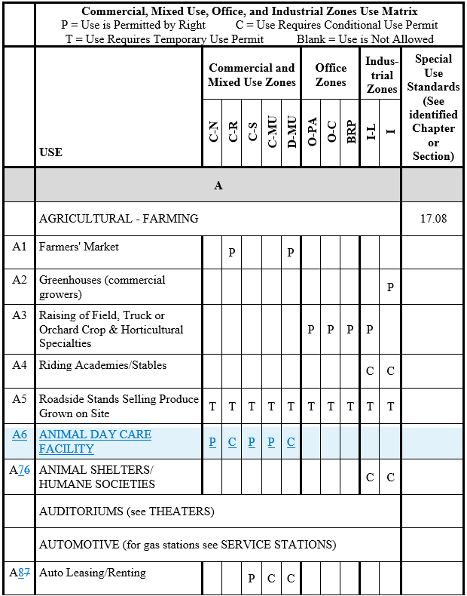
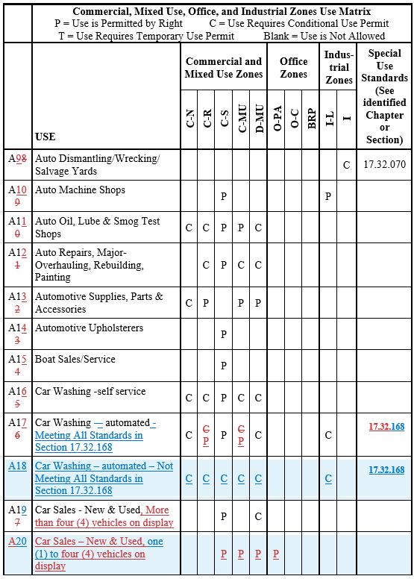
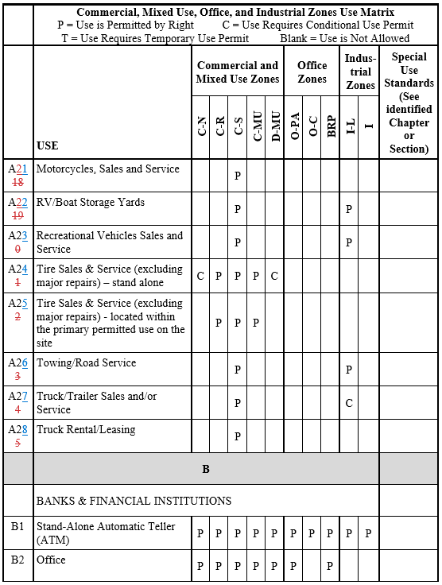

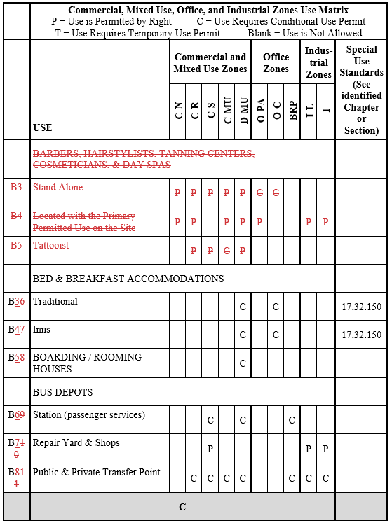

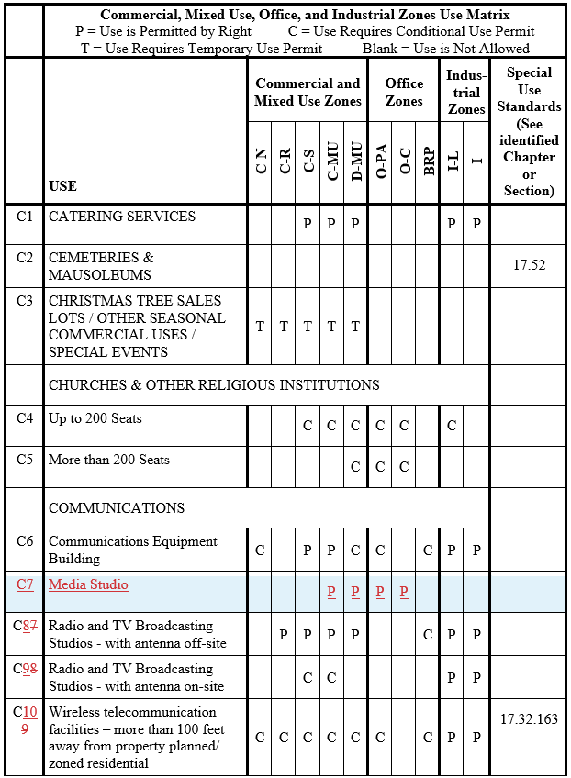
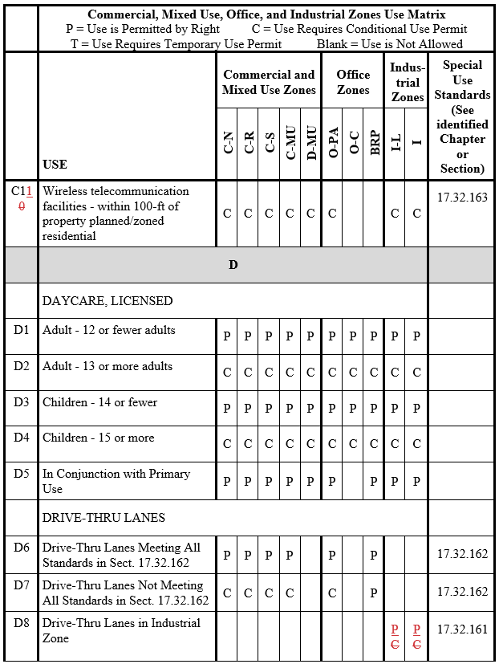

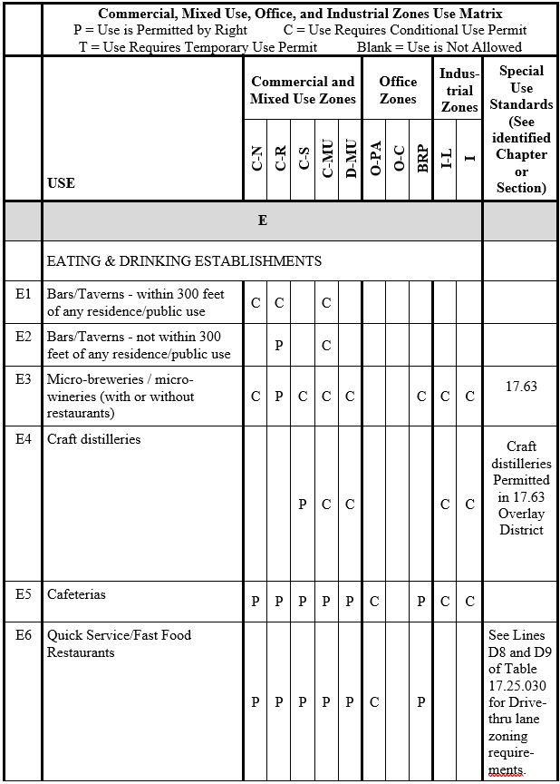

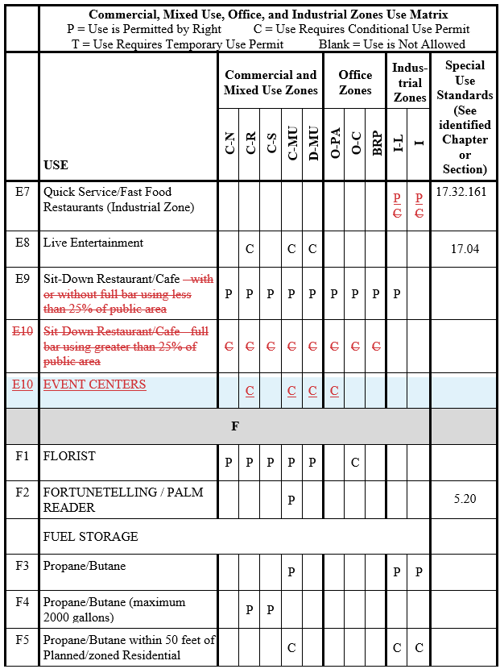

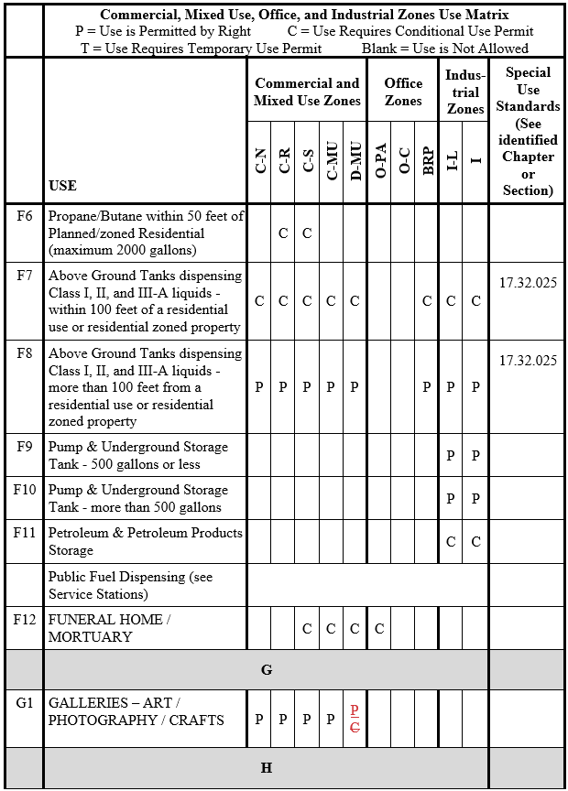

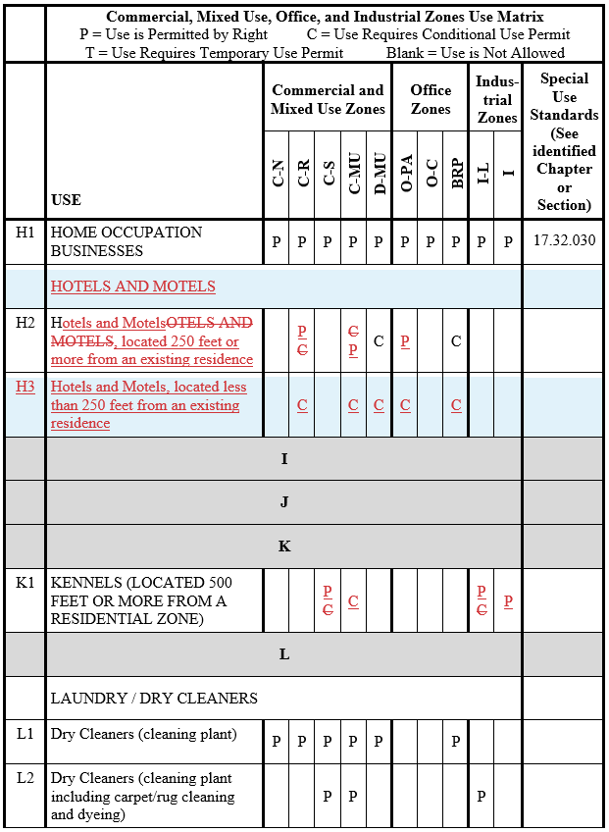

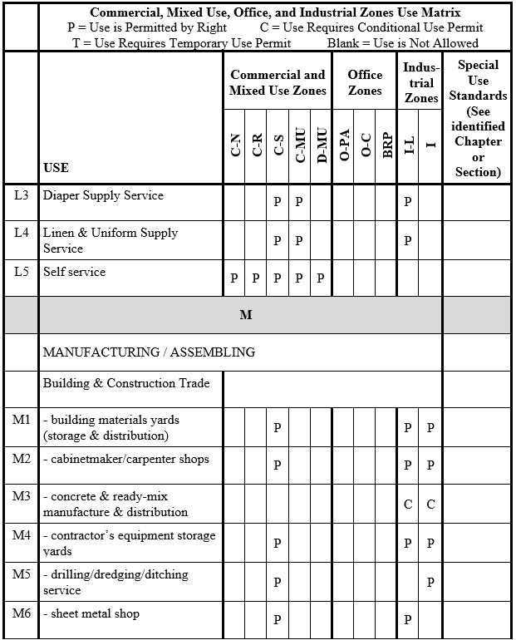

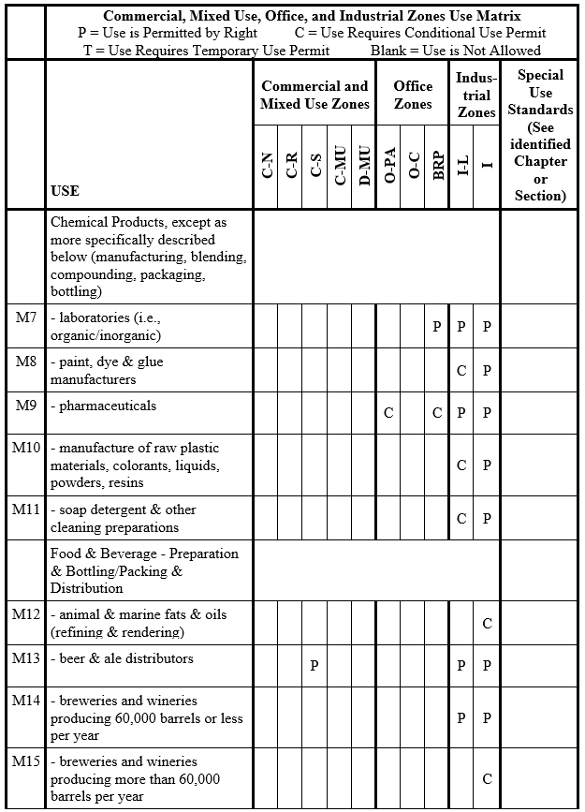

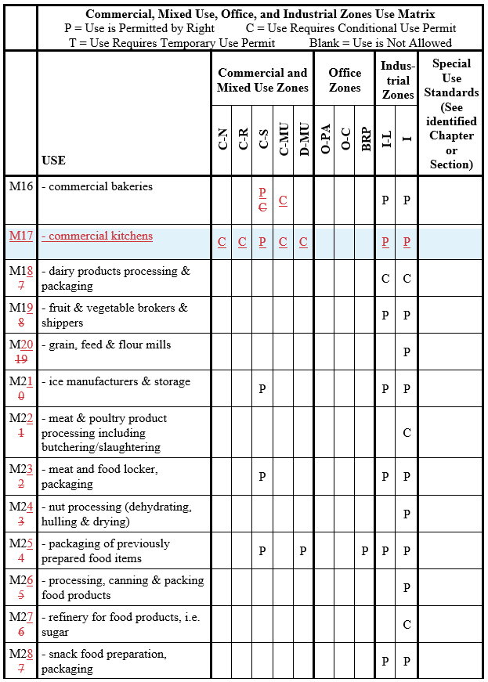

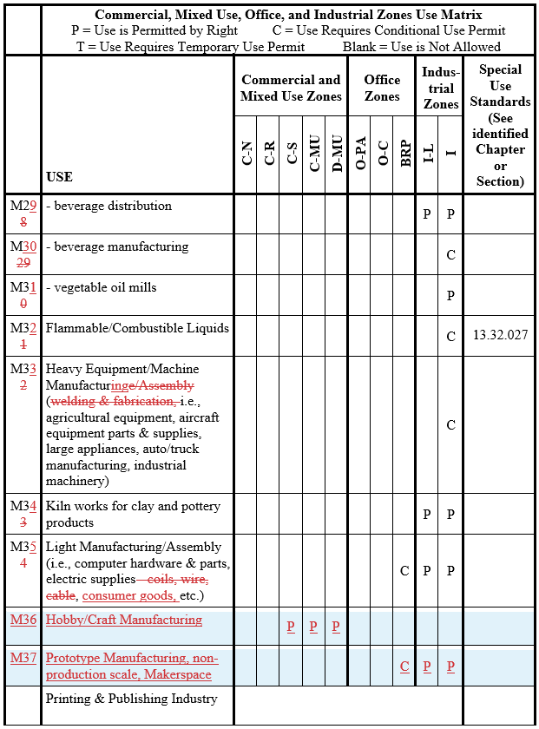

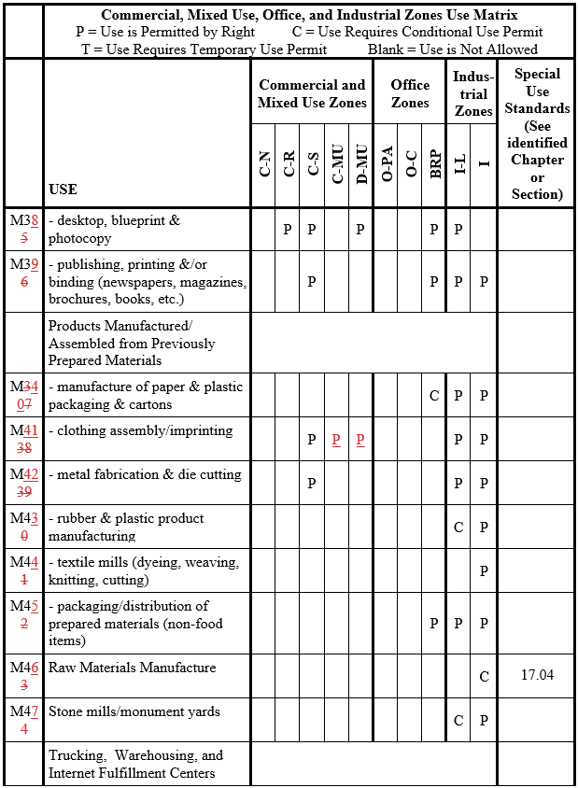

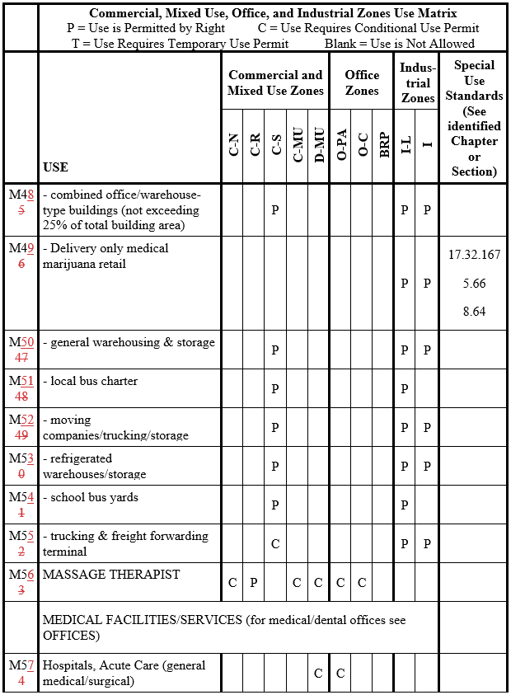

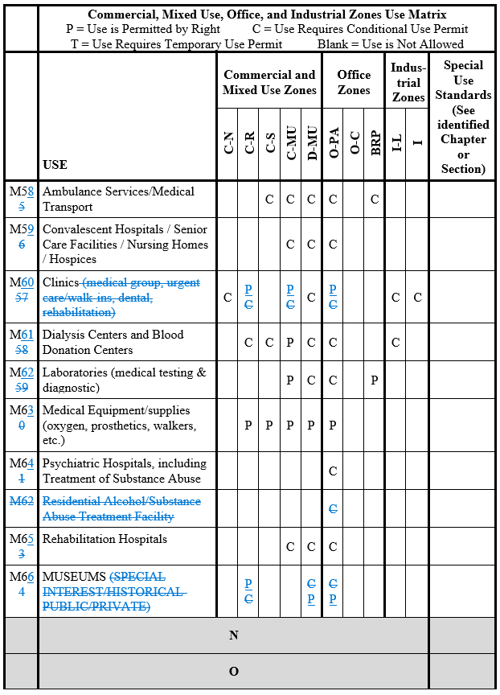

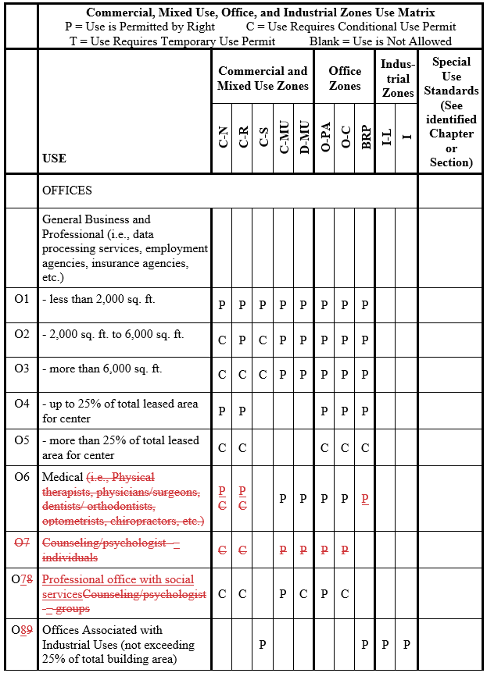
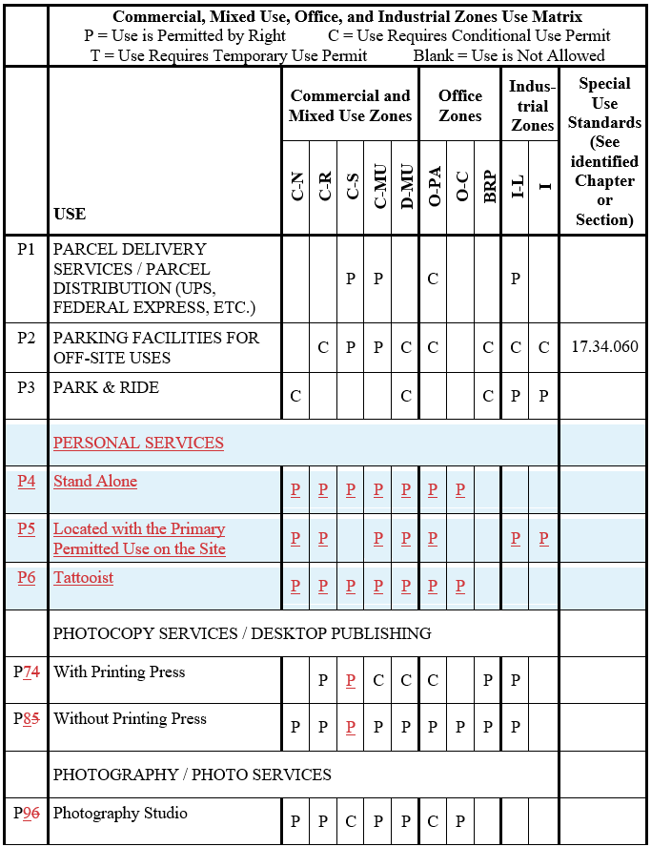

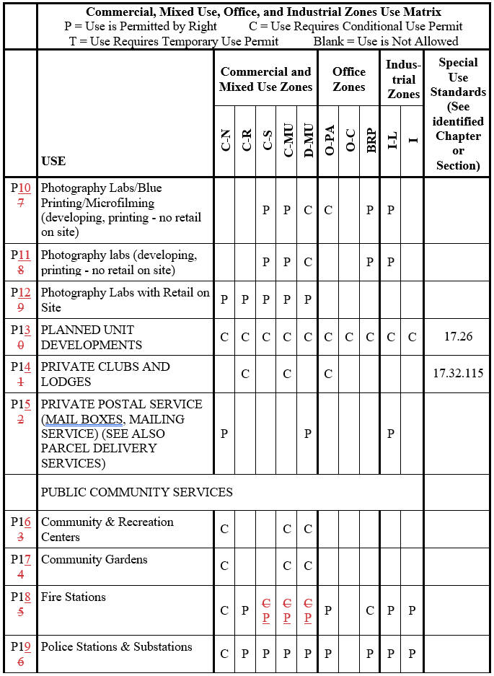

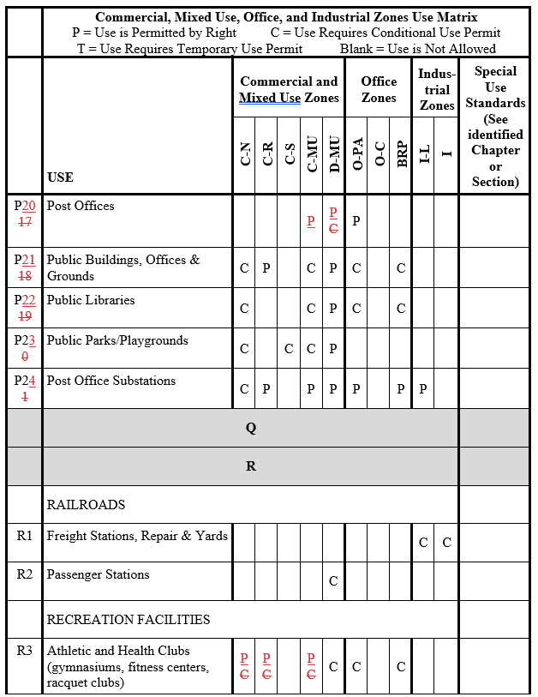

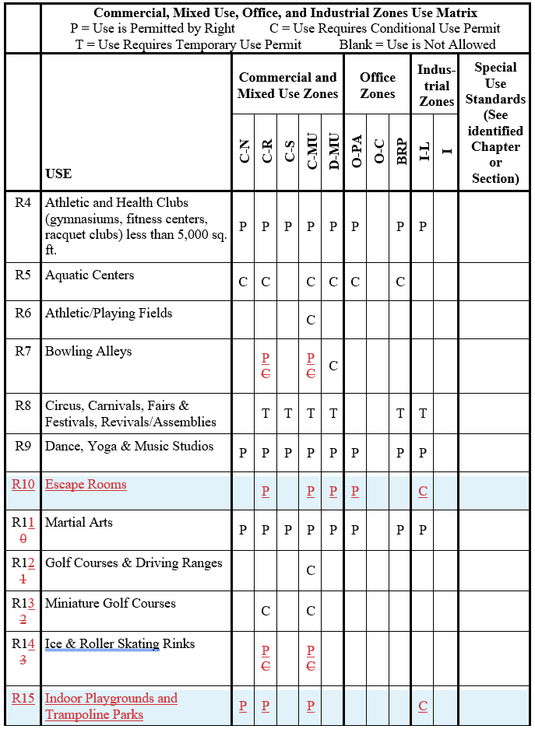
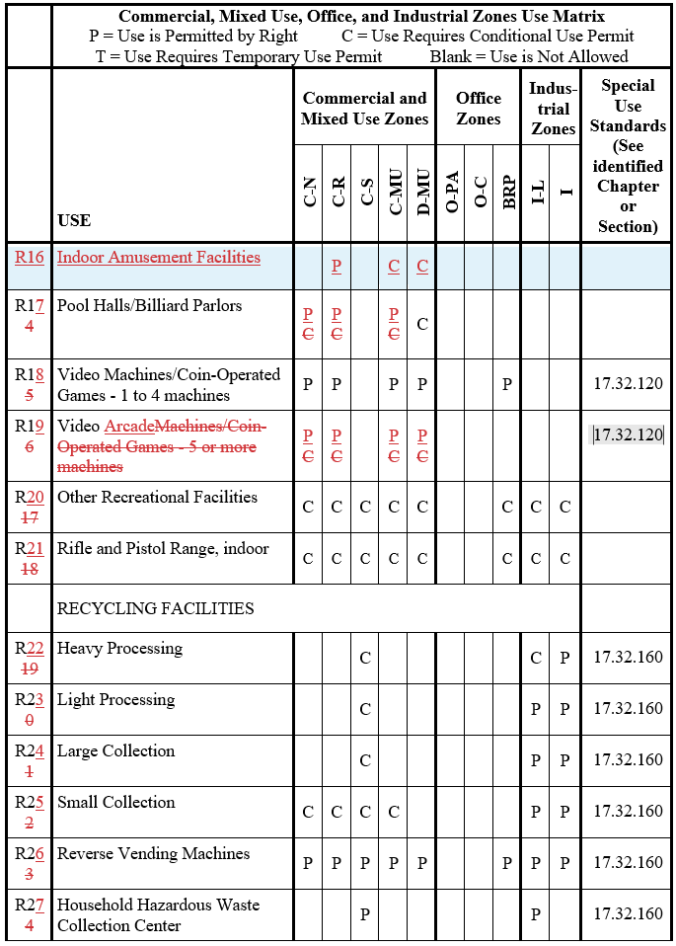

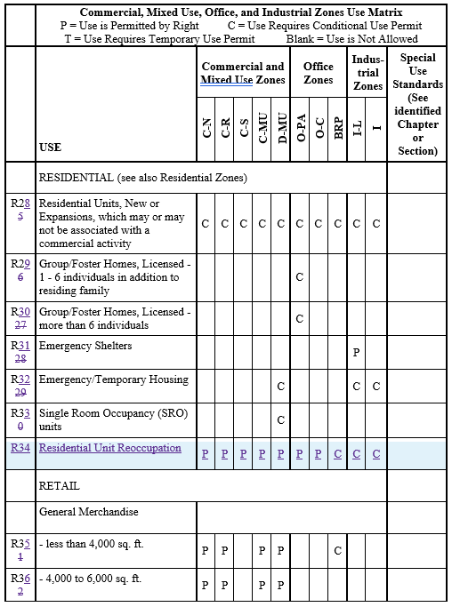
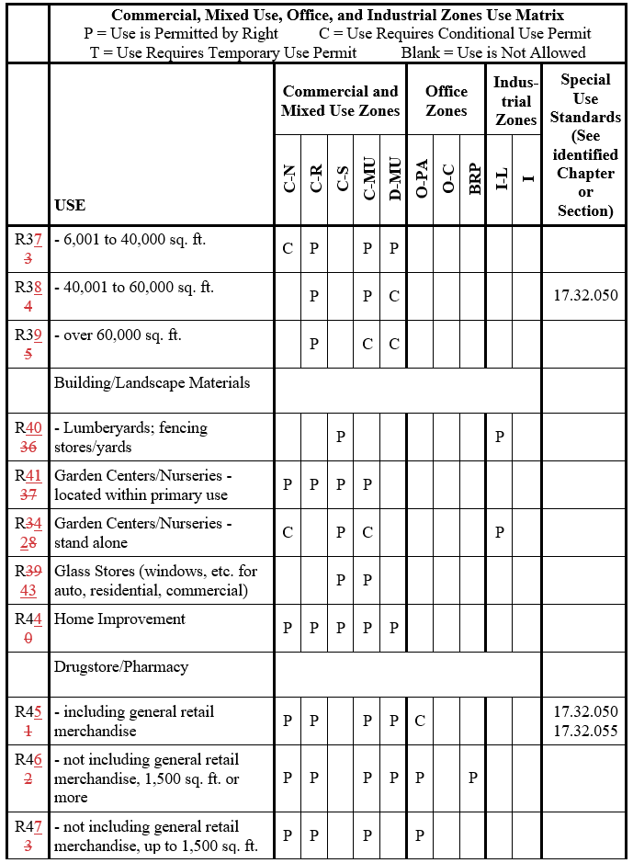
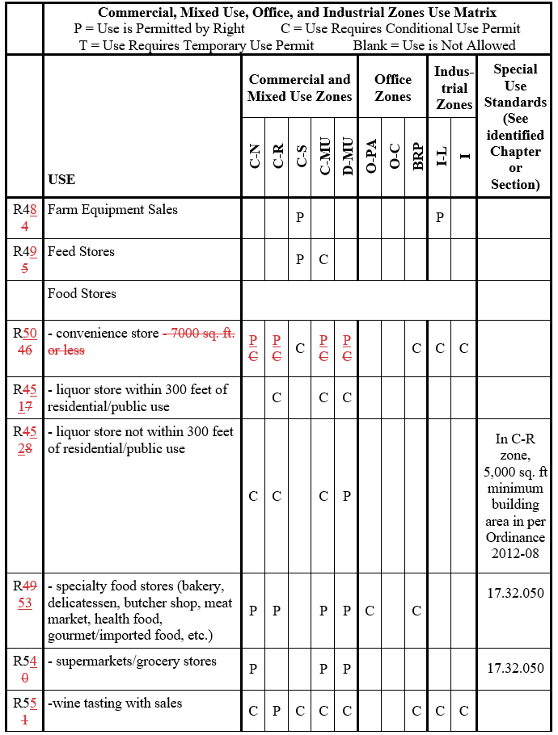
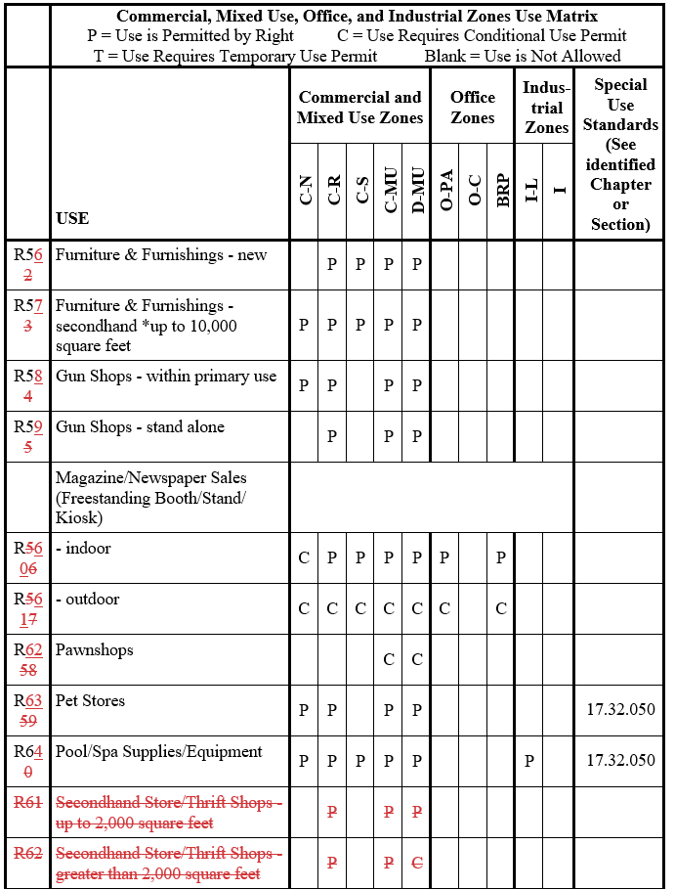

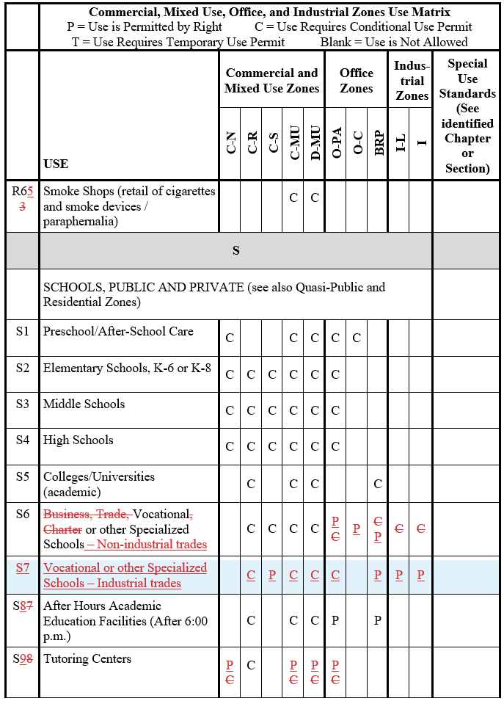

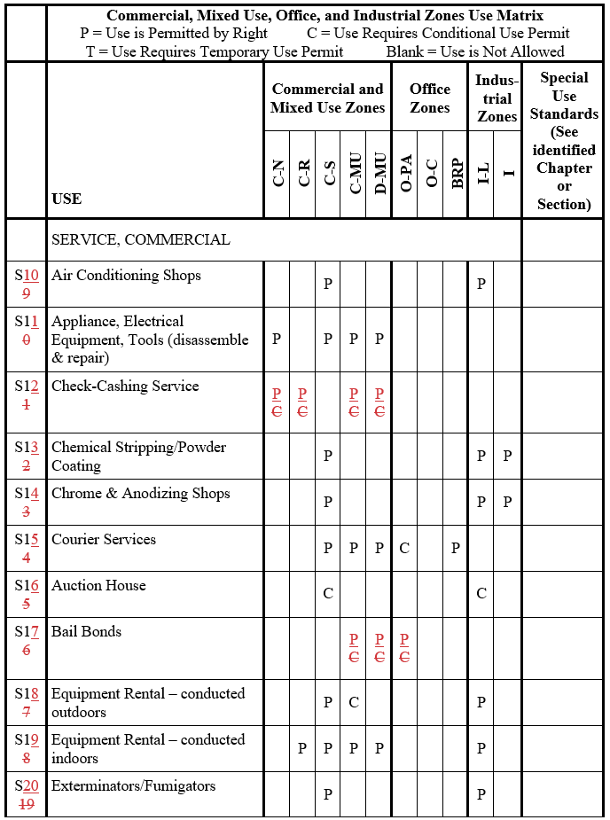
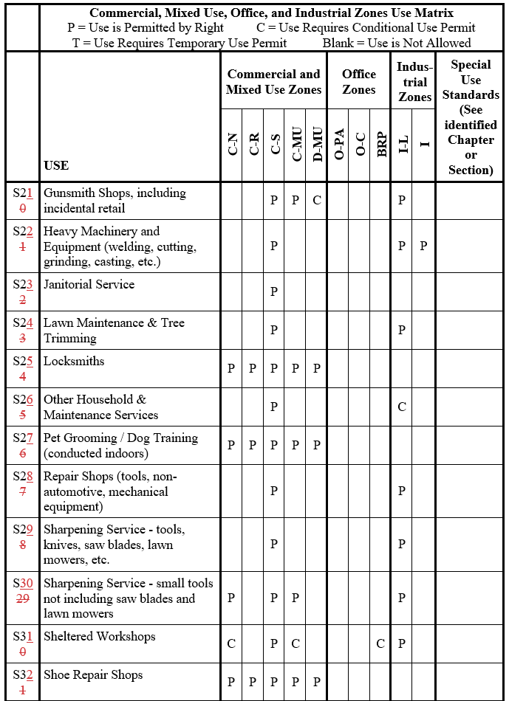

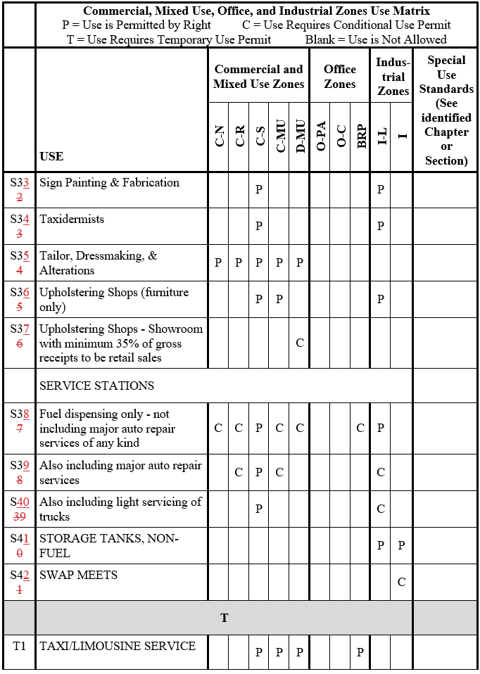

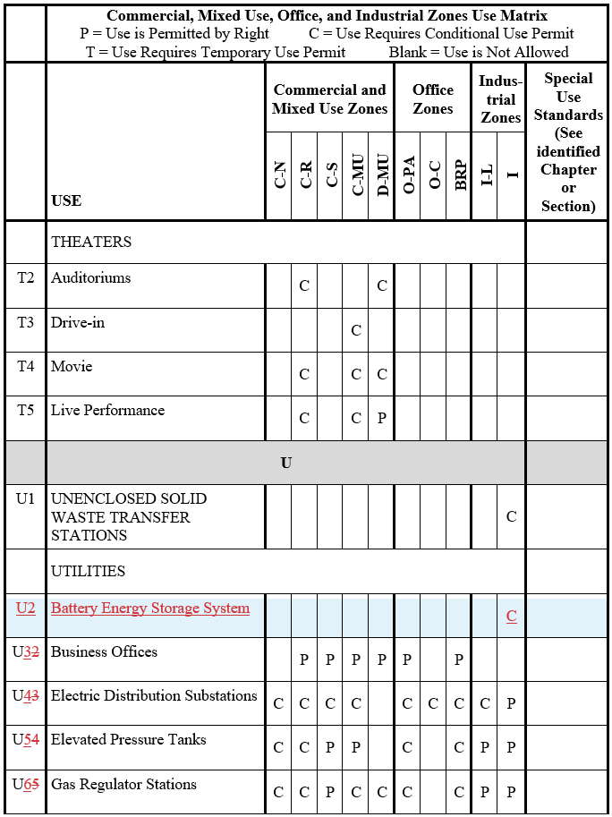

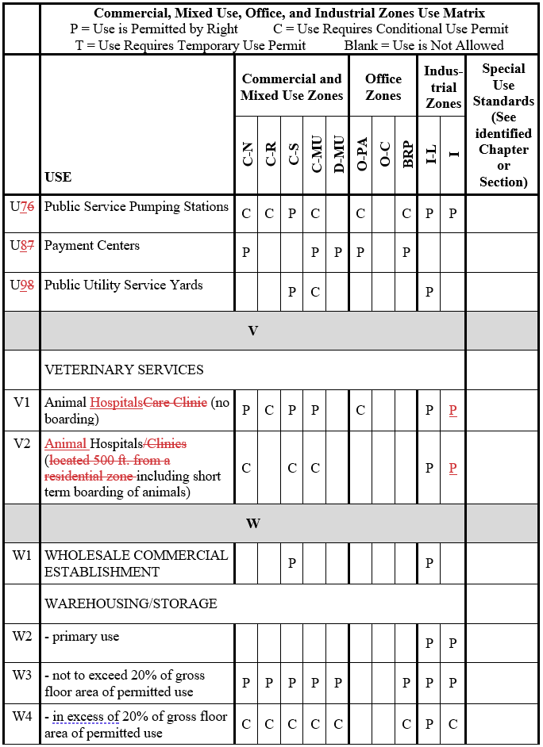

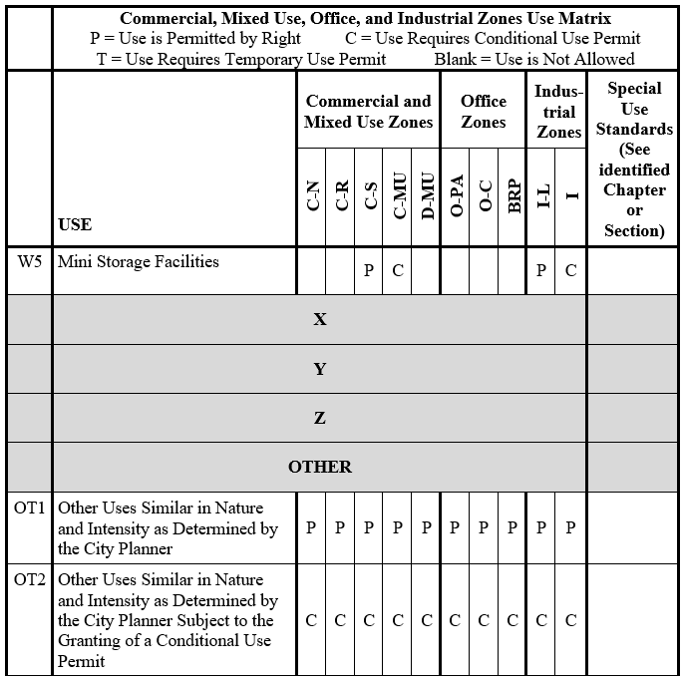

Section 5. Chapter 17.32 regarding new or modified Special Provisions.

Section 17.32.168 Automated Car Washes
A. The queue lane shall not be visible from the public right-of-way. This shall be achieved by designing the site in a manner such that the queue lane is not located parallel with public street frontages, or by incorporating screening along a queue lane to a minimum height of three feet utilizing a combination of berms, hedges, and/or landscape materials, or solid walls if necessary.
B. The queue lane for entering the car wash structure shall not be located within 25 feet of a residential-zoned property or a parcel containing an existing residence or a sensitive receptor.
C. A noise analysis addressing noise impacts in conformance with the City of Visalia’s Noise Ordinance (Chapter 8.36) shall be required and accepted by the City Planner if the car wash is located within 1,000 feet of an existing residence or a sensitive receptor. Compliance of the noise levels, subject to the Visalia Noise Ordinance, shall be verified by the acoustical consultant or their designee prior to operation.
D. For car washes requiring a noise analysis, hours of operation beyond 7:00 p.m. shall only be permissible if supported by a noise analysis that confirms the car wash will not be inconsistent with the City of Visalia’s Noise Ordinance (Chapter 8.36).
E. A traffic study which analyzes the impact of the proposed carwash on adjacent and nearby intersections may be required. The limits of this study shall be established by the City Engineer.
F. Adequate means of eliminating grease and oils from drainage systems shall be provided, such as through the installation of a sand-oil separator.
17.32.120 Video machine arcades.
It is the purpose of this section to set forth development and operational standards for arcades. Such standards are adopted to protect the public welfare from potential problems associated with the operation of video machine arcades.
A. Definitions. For the purpose of this section the following definitions shall apply:
"Video arcade" means a commercial establishment that contains five or more "video machines.” and its primary business is generated from sales occurring through use of the “video machines.” Businesses that operate “video machines” as an ancillary use are not considered “video arcades.”
"Video machine" means any machine, device or apparatus, the operation or use of which is permitted, controlled, allowed or made possible by the deposit or placing of any coin, plate, disc, slug, or key into any slot, crevice or other opening or by the payment of any fee or fees, for the use as a game, contest, which is operated through the use of electronic means with images and sounds transmitted through a cathode ray tube.
B. Permits Required.
1. Video arcades may be approved as a conditional permitted use in the C-N, C-R, C-MU and D-MU zones pursuant to Chapter 17.38 of the Visalia zoning regulations.
2. Video machines, up to four in number, may be approved by the planning department pursuant to Section 17.38.070 (temporary uses) of the zoning regulations. Such permits shall be subject to the operational criteria set forth in subsection (C) of this section.
CB. Operational Criteria.
1. Location. Video machines and arcades shall not be located closer than six hundred (600) feet to any public schools, grades kindergarten through twelfth grade.
2. Hours of Operation. Normal hours of operation shall be between the hours of ten10:00 a.m. and eleven11:00 p.m. unless alternate hours are approved by the city council as part of a conditional use permit. Machines located in businesses may be operated during normal business hours if approved by the planning department(four or fewer machines) or city council (arcades). In any case, school aged children shall be prohibited from operating video machines while school is in session.
3. Security/Supervision. The use shall be under the supervision of an adult during all hours of operation. Additional supervision or security may be required as deemed necessary by the city council under the terms of the conditional use permit. The work station of the adult attendant shall be such that the entry and immediate outside area is visible. Supervision responsibility shall extend to the public and/or parking areas in the vicinity of the arcade.
4. Alcoholic Beverages. No alcoholic beverages shall be allowed to be bought or consumed on the premises, including the public and/or private areas in the vicinity. This shall not apply to businesses that are licensed and approved for alcoholic beverage sale and use, such as a bona-fide restaurant.
5. Noise. No noise or sound generated by an arcade shall be audible outside of the arcade building.
6. Loitering. Gathering and loitering of individuals in the arcade and public and/or parking areas in the vicinity of the arcade shall be prohibited.
DC. Monitoring of Use. Periodic inspections, which may or may not be announced in advance, may be conducted by the city to ascertain compliance of any arcade with these operational standardsthe conditions of the use permit under which the arcade is operating. Violations of the conditional use permit or the provisions of this section shall be subject to enforcement under the provisions of Chapter 17.46 of the zoning regulations. Continuing violations may lead to revocation of the conditional use permit for an arcade, as set forth under Section 17.38.040 of the zoning regulations. (Ord. 2017-01 (part), 2017: prior code § 7488)

Section 6. CEQA. The project is exempt under the California Environmental Quality Act (CEQA) Guidelines section 15061(b)(3) (common sense exemption); and

Section 7. Severability. If any section, subsection, subdivision, paragraph, sentence, clause or phrase of this Ordinance, or its application to any person or circumstances, is for any reason held to be invalid or unenforceable, such invalidity or unenforceability shall not affect the validity or enforceability of the remaining sections, subsections, subdivision, paragraphs, sentences, clauses or phrases of this Ordinance, or its application to any other person or circumstance. The City Council of the City of Visalia hereby declares that it would have adopted each section, subsection, subdivision, paragraph, sentence, clause, or phrase hereof, irrespective of the fact that any one or more other sections, subsections, subdivisions, paragraphs, sentences, clauses, or phrases hereof be declared invalid or unenforceable.

Section 8. Construction. The City Council intends this Ordinance to supplement, not to duplicate or contradict, applicable state and federal law and this Ordinance shall be construed in light of that intent.

Section 9. Effective Date. This Ordinance shall take effect thirty days after its adoption.

Section 10. Certification. The City Clerk shall certify to the passage and adoption of this Ordinance and shall cause the same to be published or posted according to law.

